health & Safety notice board template pages

Introduction
These template pages were developed by the health & safety team at go2HR as a guide for employers to use when designing and enhancing the company’s Health & Safety Notice Board.
Information that is required to be posted in the workplace:
- Names of JHSC members or Health & Safety Worker Representatives
- Committee meeting minutes for the last 3 meetings
- Emergency procedures including reporting processes and contact numbers
You may wish to include other information to further enhance your notice board such as:
- Workplace Incident or injury stats and trends
- Upcoming JHSC meeting dates, times, and locations
- QR codes linking to various resources
- Policy Statements (i.e. Health & Safety, Respectful Workplace/EDI, Bullying and Harassment)
- Healthy lifestyle wellness tips (i.e. physical stretching, mental health support, self-care tips, healthy nutrition)
- Health & safety related staff perks
- Health & safety reminders or rules
- Return to work information promoting injury accommodation (i.e. modified duties available)
Consider some of these tips:
- Keep information fresh, current, and exciting to look at (use company colours and logos)
- Empower JHSC Members or Worker Health & Safety Representatives to be responsible for updating the board (especially if you have multiple boards throughout the workplace)
- Consider creating a virtual notice board to make it accessible to all staff (post QR codes in staff rooms connecting workers to the virtual board)

How to use these template pages
Blue italicized content refers to common examples of health & safety information that could be included in any given section. These examples are included to help you get started, but are in no way exhaustive. If it does not apply in your setting, you can delete it. Feel free to get creative!
Red italicized content refers to site specific information. Please delete the red text and input your workplace specifics, in order to personalize the templates to reflect your operation.
When you have finished editing, there shouldn’t be any blue or red italicized content left. Once your edits are completed, delete this introductory information before you finalize, print, and post on your health & safety notice board.
HEALTH & SAFETY
NOTICE BOARD
<Your Health & Safety Notice Board should have a posted title and dedicated space for health & safety content.
Print, cut out, and use this as a title for your board.>
COMMITTEE MEMBERS:
<replace the information and photos below with your committee members>
Name & Department:  Committee experience:  Why is H&S important to you: | Name & Department:  Committee experience:  Why is H&S important to you:
Name & Department:  Committee experience:  Why is H&S important to you: | Name & Department:  Committee experience:  Why is H&S important to you:
Name & Department:  Committee experience:  Why is H&S important to you: | Name & Department:  Committee experience:  Why is H&S important to you:
Name & Department:  Committee experience:  Why is H&S important to you: | Name & Department:  Committee experience:  Why is H&S important to you:
Name & Department:  Committee experience:  Why is H&S important to you: | Name & Department:  Committee experience:  Why is H&S important to you:
Name & Department:  Committee experience:  Why is H&S important to you: | Name & Department:  Committee experience:  Why is H&S important to you:

SAFETY COMMITTEE MEETING MINUTES
<Use this page as a placeholder for where committee meeting minutes can be posted. Minutes from the three most recent meetings must be readily available for workers to review.>

WORKPLACE INJURY STATISTICS
<Use these prompts as a way to communicate injury statistics and trends to your workers. You may also choose to include some tips, resources, or reminders that will help prevent common injuries. You may choose to communicate injury stats by the year as well as month to show the growing trends.
# OF INJURIES (YTD):  ___ | INJURIES BY AGE (YTD):  15-24: ___  25-34: ___  35-44: ___  +45: ___ | INJURIES BY DEPARTMENT:  #1: __________  #2: __________  #3: __________ | INJURIES BY JOB TITLE:  #1: __________  #2: __________  #3: __________
# OF CLOSE CALLS:  ___ | MOST COMMON CAUSES OF INJURIES:  #1: __________  #2: __________  #3: __________ | MOST COMMON INJURIES:  #1: __________  #2: __________  #3: __________ | BEST PERFORMING DEPARTMENTS  #1: __________  #2: __________  #3: __________
MOST INJURIES HAPPEN BETWEEN:  XX:XX AM – XX:XX PM | # OF WORKERS ON MODIFIED DUTIES:  ___
FOR MORE INFORMATION ON INJURY STATS, SPEAK WITH YOUR MANAGER OR SAFETY COMMITTEE REPRESENTATIVE

WORKPLACE HEALTH & SAFETY RULES
<It is common to have a list of rules that all workers must follow. Some examples are listed below, but ensure what you post is specific to your workplace and included in new worker orientation, the employee handbook, and enforced throughout the workplace.>

- No staff member walks to their car alone after 9 pm
- Do not participate in bullying and harassment
- No running or horseplay in the workplace
- Appropriate PPE must always be worn for the job
- See something, say something – report hazards to your supervisor

WORKER HEALTH & SAFETY RIGHTS
<By regulation, workers have workplace health & safety rights. It is important for an employer to empower their staff to know and exercise their rights in order to foster a positive health & safety culture.>

Worker Rights:
- Right to know about hazards in their workplace
- Right to refuse unsafe work
- Right to participate in health & safety activities

EMERGENCY REMINDERS
<Use this page to remind workers of emergency procedure information such as first aid attendant names, work schedules, and work locations, as well as important locations such as first aid kits, eye wash stations, AED’s and muster/assembly areas. You can also remind workers of incident reporting procedures including who to contact and when. You may choose to include quick step by step instructions for fire, earthquake, tsunami, active shooter emergency procedures. Try to keep it simple by reducing the actual procedure document to the basic steps. Also consider connecting workers with emergency mental health support through community or Employee Assistance Program (EAP) programs.>
First aid attendant(s) (names, work schedules, and work locations):
First aid kit location(s):
Eye wash station location(s):
AED location:
Muster station location(s):
Remember to report all incidents to your supervisor (name and contact information):
Emergency procedures:
Employee Assistance Program (EAP) contact information:

NEXT COMMITTEE MEETING IS:
<Use this page to post when the next meeting is. This will act as a reminder for the committee members, but will also give committee visibility to the rest of the workers. A great way to re-use this page is to print a blank sheet, laminate it, and use erasable marker to refresh the meeting date, time and location as months and meetings progress throughout the year.>

<date & time>
<location>
Please communicate any comments, concerns, and questions to your worker representative by the date listed above.

HEALTH & SAFETY SUGGESTIONS
<Asking for input from workers is really important as it empowers workers to get involved with workplace health & safety and gets suggestions from the group on what they would like to see. For example, ideas for worker wellness events, improvement ideas of existing processes, or identification of where the health & safety program is lacking. Having this process as anonymous helps all workers to have the opportunity to get involved by eliminating any communication barriers.>
MONTHLY HEALTH & SAFETY TOPIC
<Use this page as a placeholder for a revolving, relevant health & safety topic or quote. The topic or quote, accompanied by an information sheet, can be presented by the co-chairs at the committee meeting, and worker representatives can post the information sheet on the safety boards. For example: Preventing heat stress in summer months, preparing for winter travel in late fall, mental health support during the holidays, earthquake preparedness during the month of October (preparing for the Great Shake Out participation).>

SAFETY EXCELLENCE RECOGNITION
<Recognizing workers and front-line leadership (supervisors and middle management) for positive safety behaviour is one way to encourage all workers to enhance their safety performance. By allowing other workers to nominate each other for this recognition is an elevated way to get all workers involved. Having a recognition program like this will reinforce to all workers that safe behaviour is celebrated at your workplace.>

HEALTH & SAFETY QUICK LINKS
<Use the QR codes below to connect your workers with online resources. Add site-specific documents as well such as a link to the OHS Manual, Employee Handbook, Emergency Procedures, etc. Hyperlinks are included in each QR code for virtual notice boards.>
OHS REGULATION APP  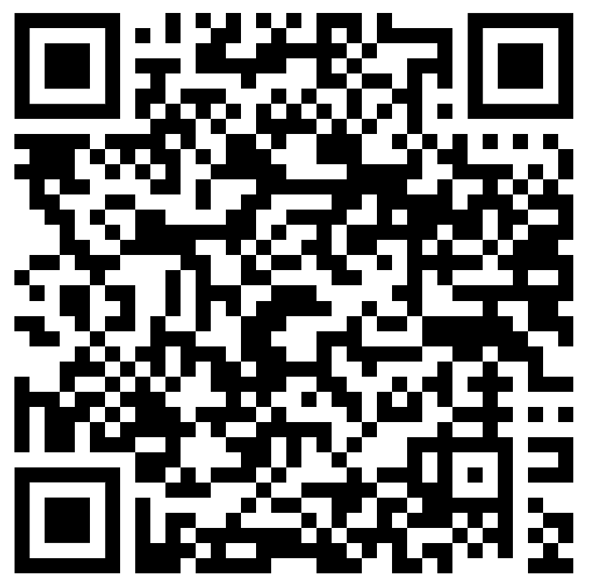 | WHMIS 2015: WORKER VIDEO  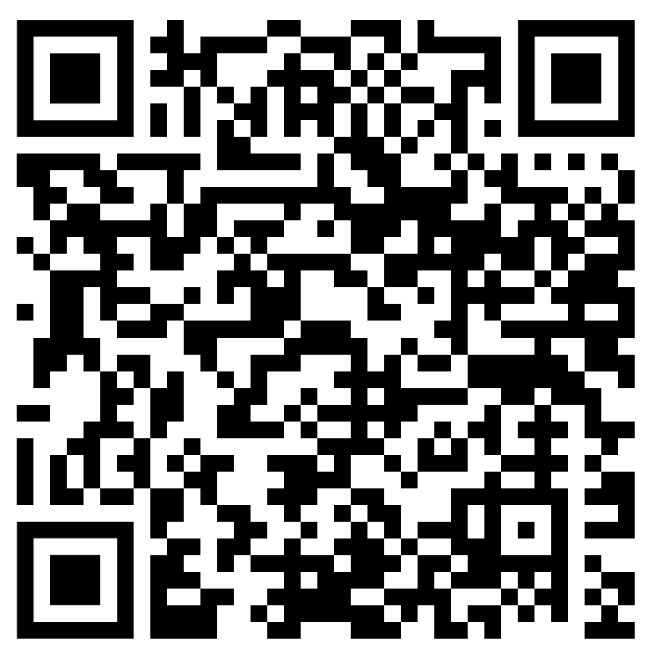 | MENTAL HEALTH SAFETY TALK VIDEOS  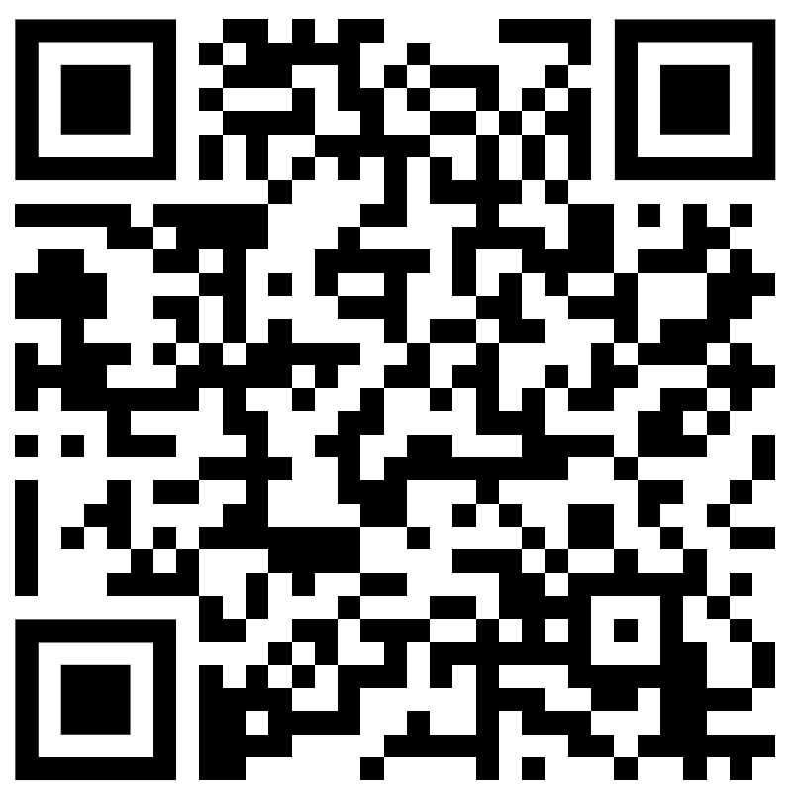
go2HR RESOURCE LIBRARY  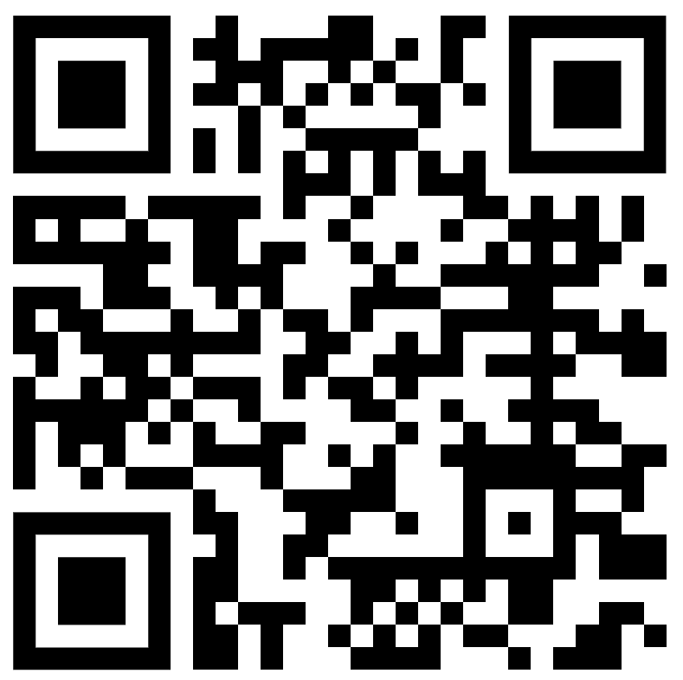 | KITCHEN SAFETY VIDEOS  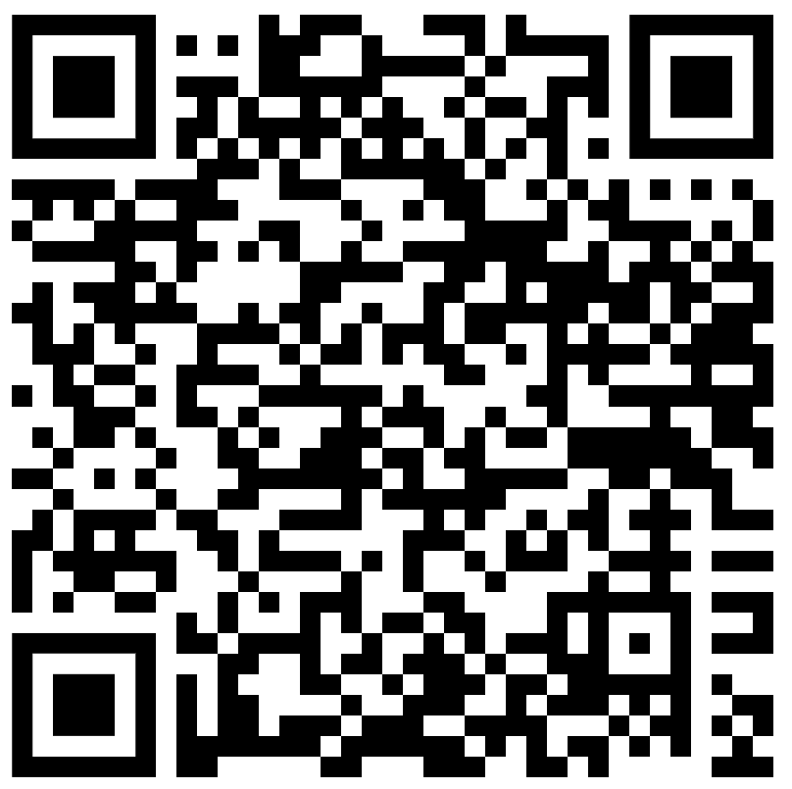 | ROOM ATTENDANT SAFETY VIDEOS  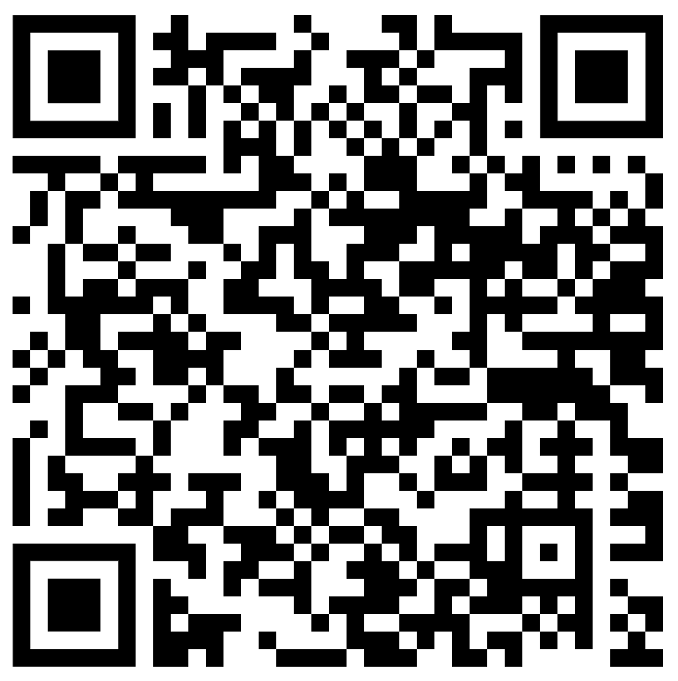
CCOHS INFO SEARCH  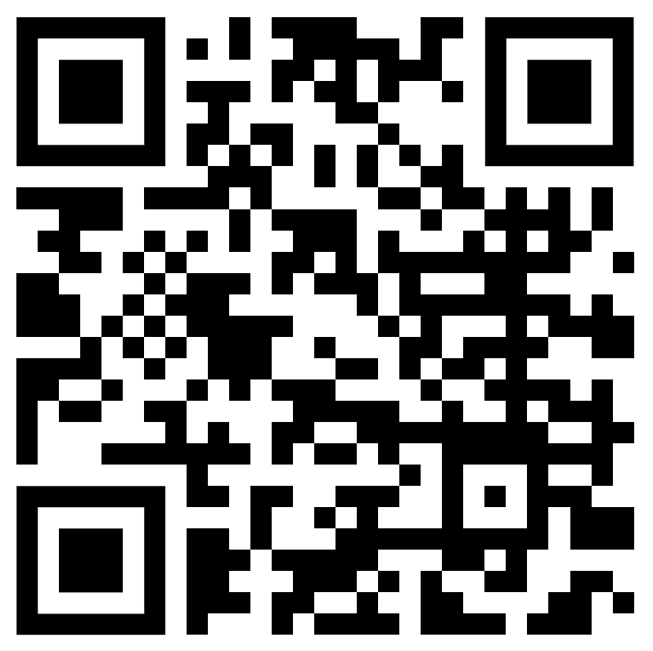 | BULLYING AND HARASSMENT VIDEOS  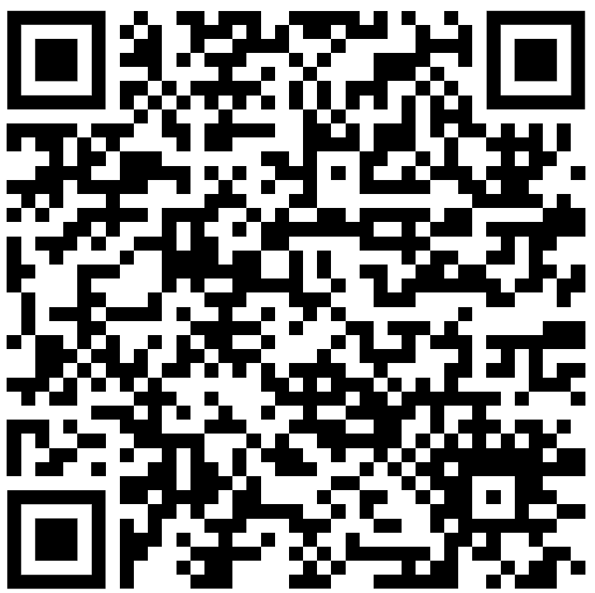 | FOUNDATIONS OF WORKPLACE SAFETY COURSE  