Manual Lifting

Instructor Guide
Safety Talk Overview
Safety Talks are a method to refresh an employee’s knowledge and skills, maintain their interest in safety and illustrate the organization’s commitment to creating a healthy & safe work environment. Safety Talks can be performed on a weekly basis or before the start of a new scope of work and should be about 15 minutes in duration. Generally, these Safety Talk meetings are led by a supervisor and should be mandatory for all crew members to attend. The content should be centred on a single topic (e.g. a safety rule, safe job procedures, recent incident, Joint Health & Safety Committee (JHSC) meeting minutes, inspection results, etc.).
go2HR developed these Safety Talks in conjunction with representatives from 11 ski hills in BC. The content is meant to be a base on which to work from, so please feel free to customize the subject matter to your own organization. If you would like to develop your own Safety Talk, please download the Safety Talk template from the go2HR website.
Topic Overview:
In BC ski areas, a large percentage of reported on-the-job accidents involve back injuries, often happen when people lift objects incorrectly. Examples include ski patrollers lifting a patient onto a toboggan; a lift attendant picking up a fallen guest; and a snowmobiler getting their snowmobile unstuck.
Moving any load can cause chronic lower back injury by exerting stress on the spine and back muscles. Back injuries can be debilitating and long-term, so think smart and lift correctly.
Demonstration and Discussion Topics
Discuss the hazards associated with manual lifting.
Tour the work area with workers pointing out where the accidents can occur
Distribute the “Do’s & Don’ts” section of this handout.
Use the “Instructor Guide” section of the handout as your discussion guide and the “Safety Talk Record” to document the meeting.
Discuss how accidents can happen.
Remind employees that they are required to wear adequate personal protective equipment.
Explain what can be done to minimize the risk of accidents (do’s & don’ts in handout)
Emphasize that following safe work procedures is mandatory.
Make it real by telling at least two true stories of injuries from your experience.
Discuss the attitude of “it won’t happen to me”. Remind them that an injury can and will happen if they take shortcuts or are careless.
Answer any questions or concerns they might have.
Set a good example by working safely at all times.

Manual Lifting

SAFETY TALK RECORD
Discussion Leader: |  |  | Date:
Department: |  |  | Time:
Attendees (Please print your name and sign beside it. If you are a contractor, also include your company name):
Near Miss/Incidents and Investigations Reviewed: (None this month )
(Industry alerts can be discussed here as well)

Safety Topic Discussed:
Title: |  |  |  | Date:
Any questions or concerns from workers?

Action Needed: | Person responsible: |  |  |  | Due Date: |  | Completed Date:
Reviewed By:
Supervisor/Manager Print Name & Sign: |  |  |  |  | Date:

Manual Lifting

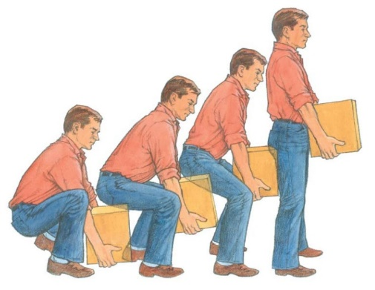
In BC ski areas, a large percentage of reported on-the-job accidents involve back injuries, often happen when people lift objects incorrectly. Examples include ski patrollers lifting a patient onto a toboggan; a lift attendant picking up a fallen guest; and a snowmobiler getting their snowmobile unstuck.
Moving any load can cause chronic lower back injury by exerting stress on the spine and back muscles. Back injuries can be debilitating and long-term, so think smart and lift correctly.

Do’s:
- Before you lift, consider how you could avoid heavy lifting, if there are resources available to assist you. Examples include mechanical aids such as a dolly, crane and pallet jack (if you’ve been trained to do so); asking someone for assistance; using back support; reconfiguring the work area to avoid awkward positions; and adding grips to objects being handled.
- Once you’ve decided to lift, inspect the work area and route for potential hazards or spills that could cause an accident. Clean up when necessary and keep pathways as straight as possible.
- Muscles should be warmed up gradually and lightly stretched before starting any physically strenuous work.
- Place your feet apart for good balance and bend the knees.
- Lift gradually with your legs and hips, keeping abdominals tight. Lift smoothly and without jerking.
- Keep your back straight.
- Turn with your feet, not your hips or shoulders. Twisting can overload your spine.
- Lower the load by bending your legs – not your back.
- Take your time.
- Keep the load close to the centre of your body.
- If you see somebody undertaking heavy, awkward or repetitive lifting, assist them if possible. Ask for assistance when you need it, and do not hesitate to report difficult or hazardous lifting/moving jobs that can be simplified.

Manual Lifting

Don’ts:
- Don’t rush into heavy lifting.
- Don’t lift with the back or waist.
- Don’t lift in a jerking manner.
- Don’t do heavy or repetitive lifting if there is a mechanical alternative.
- Don’t lift more than you can easily handle.
- Don’t challenge your lifting abilities.
- Avoid lifting higher than your shoulder height.
- Never over exert yourself unnecessarily.

