Form C: Physician Assessment — Return-to-Work Planning

Employee Authorization to Release Information
I, (print full name), hereby authorize my attending physician to release the information below to my employer, [EMPLOYER], for the purpose of planning my work duties as part of [EMPLOYER’S] return-to-work program.

Employee’s signature Date

Areas of injury/body parts | Does the employee have any functional limitations or restrictions as a result of the injury?  No  Yes, please see below to provide more information
Next appointment date | If the employee has limitations or restrictions, how long do you recommend these considerations?  days
Please complete the following chart or circle the appropriate standard restrictions in the Guidelines for Modified Work (see next page).

Physical Capacity
Capacity  (Complete only the sections where there is a limitation or restriction related to an injury or illness) | Effort  (If applicable, for example, 2 kg) | Frequency  (If applicable)
Standing
Walking
Sitting
Lifting from floor to waist
Lifting from waist to shoulder
Lifting overhead
Bending or twisting
Pushing or pulling
Vibration
Environmental exposure
Substance exposure
Gripping
Precision work with hands
Speaking
Driving
Operating motorized equipment
Quick movement
Speech
Hearing
Vision
Smell
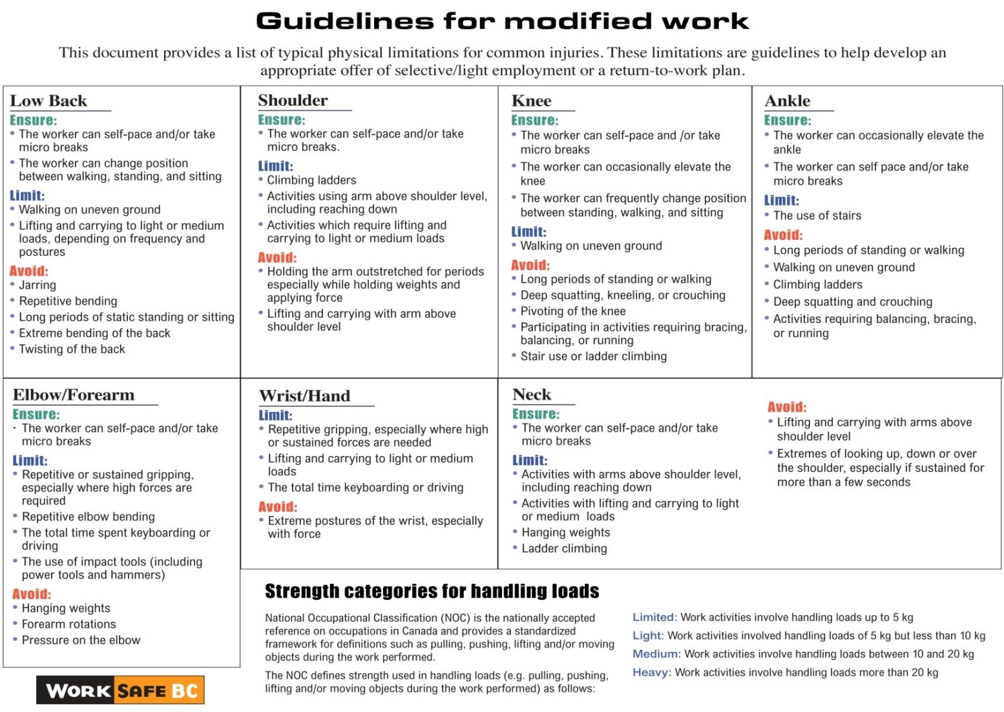

Please provide the completed form to your patient at the end of the appointment.
Please fax to [EMPLOYER] at or email at __ and fax a copy to WorkSafeBC at 1 888 922-8807 or 604 233-9777.

Physician’s signature Date

Physician’s name (print) Telephone number

