Form J: Modified Work List
A list of modified work is based on an inventory of tasks within each job and an assessment of whether those tasks are within standard restrictions. This information is ideally stored in an electronic format and updated regularly as new job tasks and work procedures emerge.
Each supervisor or manager should have an awareness of each job and essential tasks as they relate to standard restrictions, to support accommodation within the employee’s own job or work group as much as possible.
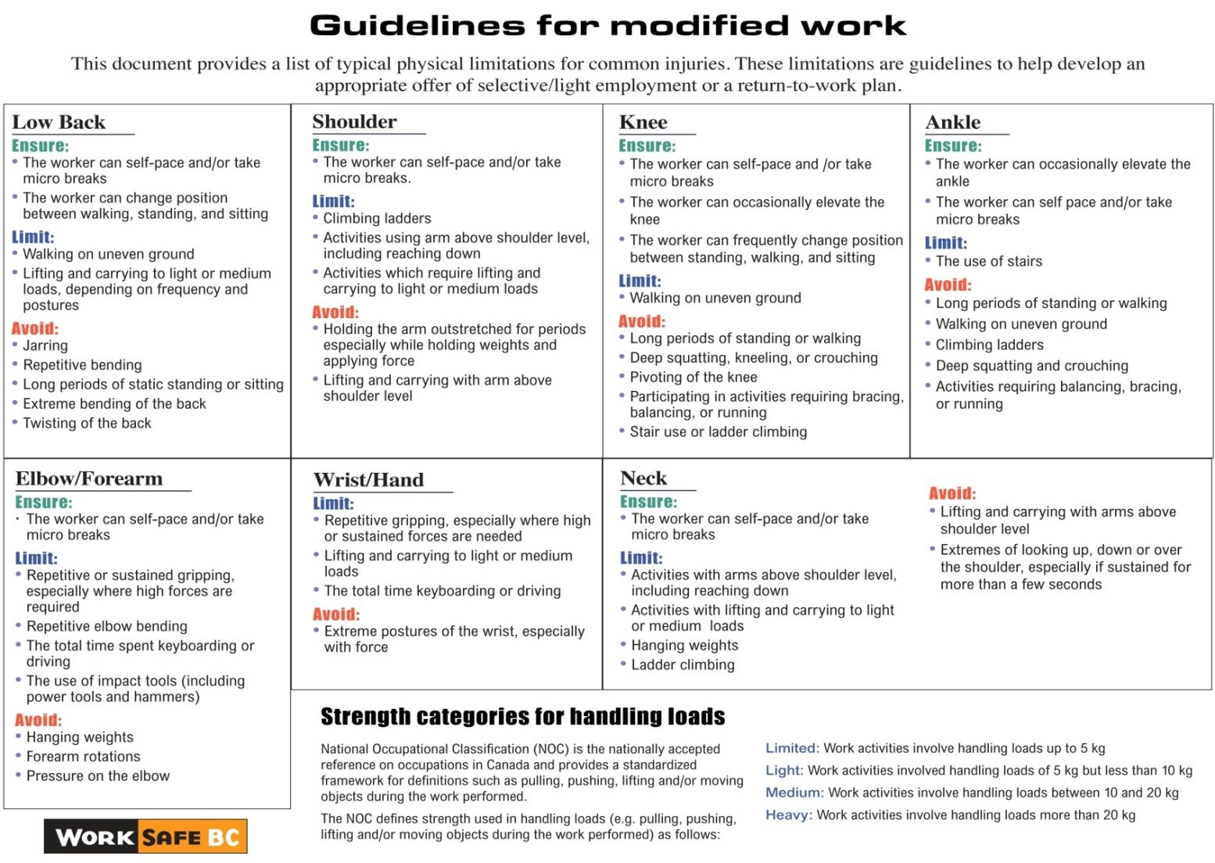

Sample of Modified Work List for Food and Beverage Operations
Please check off the duties that will be part of the modified work offer. Add or delete items on this list as necessary for your specific operation.
Task/duty | Modified work offer
Greeting guests
Cutlery presets (roll-ups)
Table settings
Cleaning and refilling salt and pepper shakers and sugar bowls
Answering telephones, folding menus, changing menu covers
Light cleaning
Taking takeout orders
Packing takeout orders
Service audits, silent guest audits
Health and safety checklists
Market analysis — getting menus from other restaurants
Sorting guest comments
Updating log books
Tidying offices
Filing, including pulling files to be recycled
Quality checks
Updating MSDS binders
Office work, such as helping with paperwork
Monthly safety audits
Sorting cutlery
Polishing glassware
Organizing storage room
Cleaning entrances
Salting walkways (winter)
Picking up garbage (spring/summer)
Helping prep
Cleaning tables
Portioning

