Form D: Modified Work Offer
Date:
Date of injury:
Employee:
[EMPLOYER] is proud to have a return-to-work (RTW) program. The purpose of this program is to minimize the negative effects of work-related injuries or illnesses. To facilitate your return to work, we are immediately offering modified duties that are in keeping with standard precautions related to your injury. Your duties will be reviewed further once we have received the completed Form C: Physician Assessment — Return-to-Work Planning and any comments your physician may have regarding this offer to ensure your safe return to work.
Based on [EMPLOYER’S] current understanding of [EMPLOYEE’S] injury, modified duties will be provided in accordance with the attached guidelines for modified work as they relate to standard guidelines for modified work (see next page).
Low back
Shoulder
Knee
Ankle
Elbow/forearm
Wrist/hand
Neck
Limited | Light | Medium | Heavy
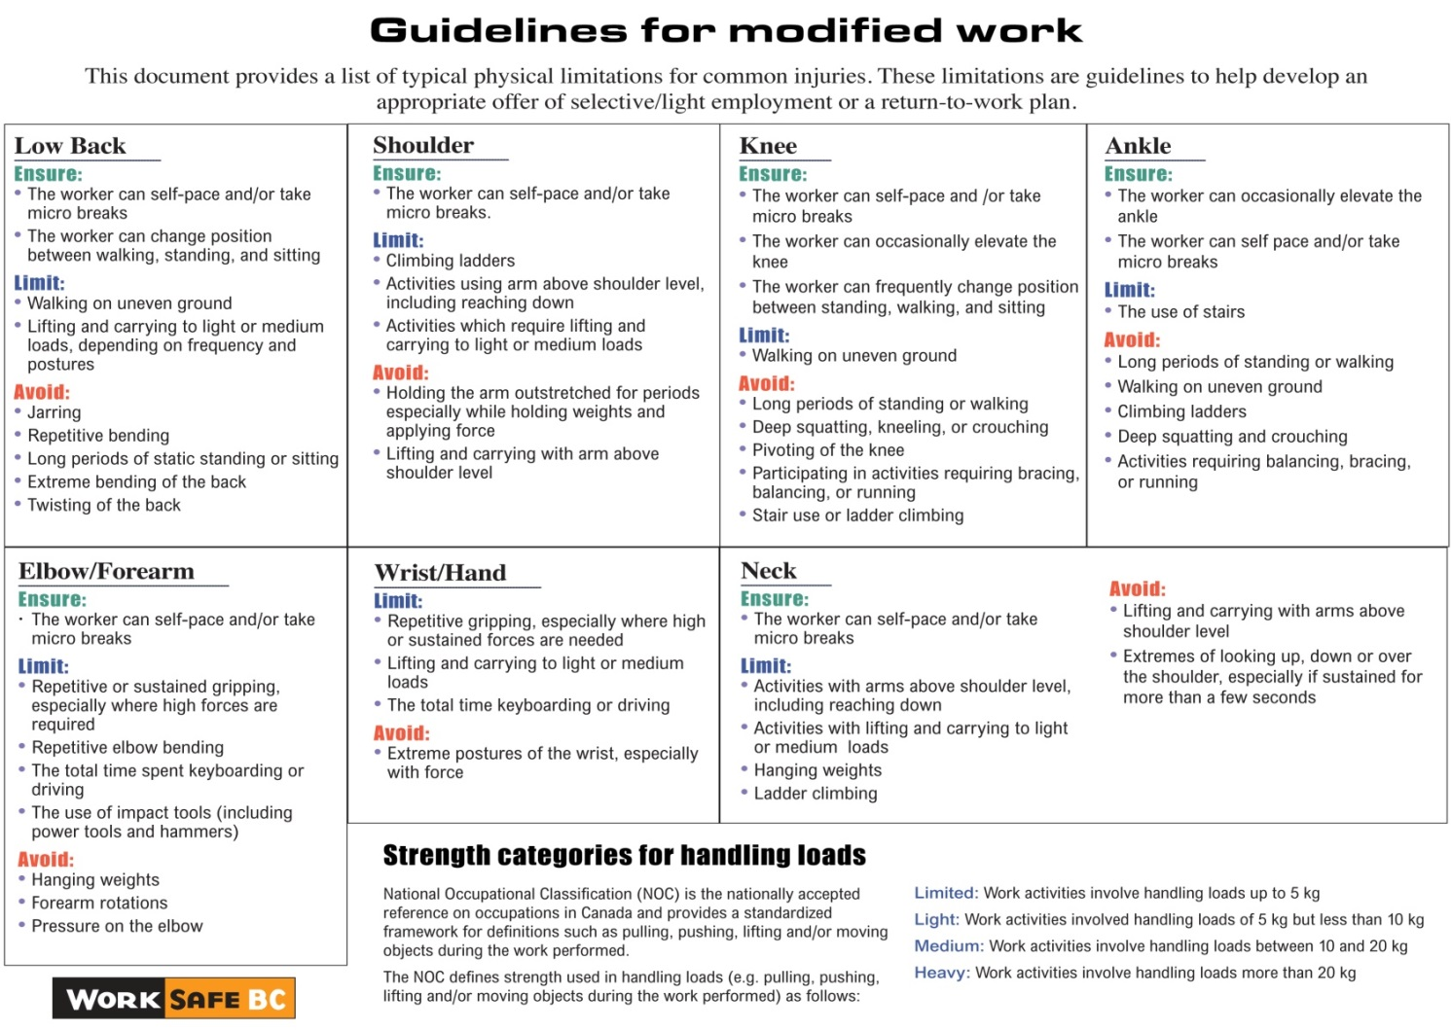

The suitable modified work in this offer is available immediately, or at the start of your next scheduled shift, at no wage loss as follows:

Job title:

Job Duties
Enter information regarding changes to duties or alternate duties:

Start date: Immediately or first scheduled shift after the date of injury
Hours:
Review: After the first full day and again after the first week
If you find any aspect of your job unsuitable or find you are unable to increase your duties, you are required to advise your supervisor immediately. Do not wait for a scheduled review time. During your RTW program, ongoing communication is necessary to assist with your successful return to work. Other duties may be assigned if the duties are within the restrictions noted above.

Employee’s Acknowledgement of Modified Work Offer
I, the undersigned, am claiming that I have suffered a work-related injury while performing duties at [EMPLOYER]. By signing below, I acknowledge that a modified job has been made available to me, at no wage loss. This job has been offered using standard restrictions for my area of injury and may be further modified upon receipt of the completed Physician Assessment form or comments from my physician. I hereby consent to my attending physician’s release of information to my employer for the purpose of planning my work duties. I understand that it is my responsibility to provide this information to my physician for his or her review. Should the appointment with my physician extend beyond my regularly scheduled shift, I am to report to my supervisor on my next scheduled working day for the start of the shift.

Employee signature Date

Physician’s Comments
Is there any reason to believe that the modified work offer poses a risk to the employee or significantly exceeds his or her functional abilities as a result of the current work injury? | No  Yes  (please explain)
Comments:

Physician signature Date

Physician name (print) Telephone number

