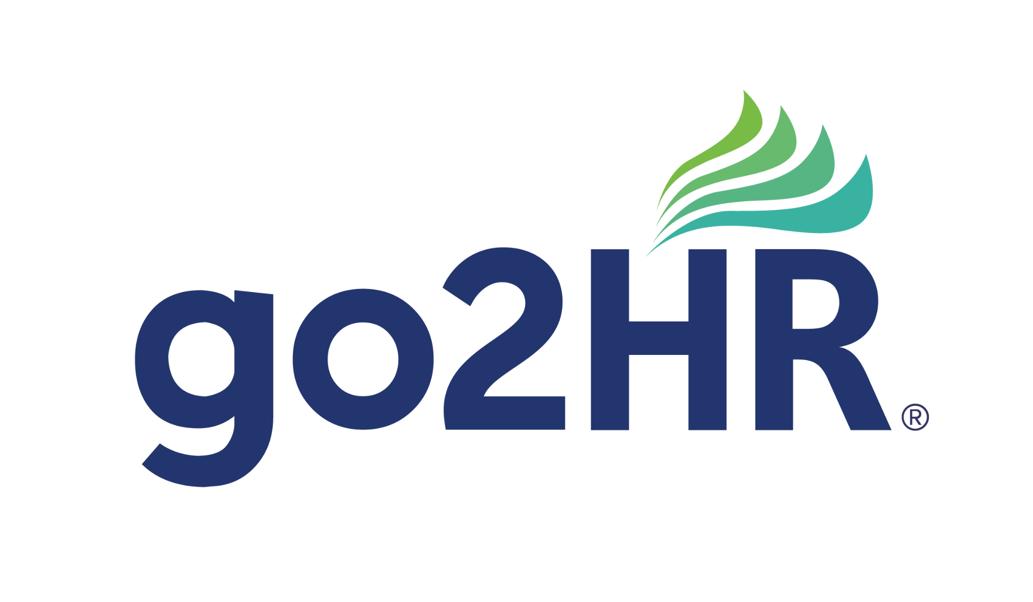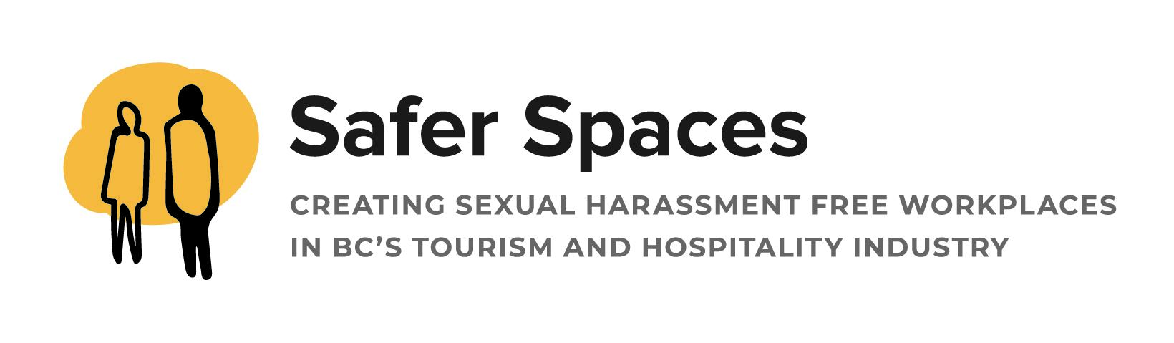
go2HR’s Safer Spaces Holiday Toolkit:
Audience: tourism and hospitality employers and workers
Goal: To educate tourism and hospitality employers and workers about working safely during the holiday season. The holidays are the busiest time for the industry and employers and workers should feel safe and respected while learning how to recognize and respond to inappropriate behaviour at staff parties and during shifts as they work with guests.
Tools: Download Safer Spaces vignettes to attach to your social media posts. These vignettes are like comic strips. On Instagram, you can attach them as a slideshow. You can only attach multiple images to a photo gallery on LinkedIn and Facebook. You cannot make a slideshow on their channels. When attaching the images, make sure they are in the correct order so that it reads like a comic strip.
Our vignettes are also available to download as a poster to add to your staff bulletin board for your workers to see.
Downloads: Here are the direct links to download resources.
Code of Conduct: https://www.go2hr.ca/wp-content/uploads/2023/04/CodeofConduct.pdf
Poster of the 4 D’s of Bystander Intervention:
https://www.go2hr.ca/wp-content/uploads/2023/06/go2HR-SaferSpacesPoster-230228-D1-1.pdf
Guest Harassment Poster: https://www.go2hr.ca/wp-content/uploads/2023/11/SaferSpacesHolidayCampaign-staff-harassment.pdf
Staff Harassment Poster: https://www.go2hr.ca/wp-content/uploads/2023/11/SaferSpacesHolidayCampaign-guest-harassing-staff.pdf
Tags: When you are posting, please tag go2HR in your posts.
- Instagram: @go2hr
- LinkedIn: @go2hr – the resource in tourism
- Facebook: @move on up with a career in tourism

SAFER SPACES – INAPPROPRIATE STAFF BEHAVIOUR
DOWNLOAD AND ATTACH STAFF HARASSMENT SOCIAL IMAGES
Channel | Content
Instagram | At the holiday staff party, Mark told an inappropriate joke about Anna which made her feel really uncomfortable.  In @go2HR’s Safer Spaces online course, we teach how important it is for #tourism and #hospitality employers to have a Code of Conduct. By implementing a Code of Conduct, employers can train staff on appropriate behavior and promote a psychologically safe workplace.  Click here to download the resource and build your Code of Conduct today.  Tip: Download this poster and post it on your bulletin board, so staff can learn more about how to support a coworker who tells you about being the subject of inappropriate jokes.  #safetyatwork #BCtourism
Facebook | At the holiday staff party, Mark told an inappropriate joke about Anna which made her feel really uncomfortable.  In @go2HR’s Safer Spaces online course, we teach how important it is for #tourism and #hospitality employers to have a Code of Conduct. By implementing a Code of Conduct, employers can train staff on appropriate behavior and promote a psychologically safe workplace.  Click here to download the resource and build your Code of Conduct today.  Tip: Download this poster and post it on your bulletin board, so staff can learn more about how to support a coworker who tells you about being the subject of inappropriate jokes.  #safetyatwork #BCtourism
LinkedIn | At the holiday staff party, Mark told an inappropriate joke about Anna which made her feel really uncomfortable.  In @go2HR’s Safer Spaces online course, we teach how important it is for #tourism and #hospitality employers to have a Code of Conduct. By implementing a Code of Conduct, employers can train staff on appropriate behavior and promote a psychologically safe workplace.  Click here to download the resource and build your Code of Conduct today.  Tip: Download this poster and post it on your bulletin board, so staff can learn more about how to support a coworker who tells you about being the subject of inappropriate jokes.  #safetyatwork #BCtourism
Newsletter | While holiday staff parties are fun to celebrate with your coworkers, making inappropriate jokes isn’t. Managers should implement a Code of Conduct and train staff on appropriate behavior to promote a psychologically safe workplace.  Click here to download the resource and build your Code of Conduct today.  Tip: Download this poster and post it on your bulletin board, so staff can learn more about how to support a coworker who tells you about being the subject of inappropriate jokes.

SAFER SPACES – GUEST HARASSMENT
DOWNLOAD AND ATTACH GUEST HARASSMENT SOCIAL IMAGES
Channel | Content
Instagram | Guests are booking their holiday party and while celebrating is fun, harassing staff isn’t. This season, #tourism and #hospitality employers can train staff on how to deal with difficult customers.  Stacy did the right thing talking to her coworker after a guest behaved inappropriately. Managers can quickly print out @go2HR poster illustrating the 4 D’s of Bystander Intervention to train staff how to safely intervene. Give the gift of respectful workplaces this holiday season so that you and others feel psychologically safe.  Click here to download the 4 D’s of Bystander Intervention poster.  Tip: Download this poster and post it on your bulletin board, so staff can learn about bystander intervention.  #safetyatwork #BCtourism
Facebook | Guests are booking their holiday party and while celebrating is fun, harassing staff isn’t. This season, #tourism and #hospitality employers can train staff on how to deal with difficult customers.  Stacy did the right thing talking to her coworker after a guest behaved inappropriately. Managers can quickly print out @go2HR poster illustrating the 4 D’s of Bystander Intervention to train staff how to safely intervene. Give the gift of respectful workplaces this holiday season so that you and others feel psychologically safe.  Click here to download the 4 D’s of Bystander Intervention poster.  Tip: Download this poster and post it on your bulletin board, so staff can learn about bystander intervention.  #safetyatwork #BCtourism
LinkedIn | Guests are booking their holiday party and while celebrating is fun, harassing staff isn’t. This season, #tourism and #hospitality employers can train staff on how to deal with difficult customers.  Stacy did the right thing talking to her coworker after a guest behaved inappropriately. Managers can quickly print out @go2HR poster illustrating the 4 D’s of Bystander Intervention to train staff how to safely intervene. Give the gift of respectful workplaces this holiday season so that you and others feel psychologically safe.  Click here to download the 4 D’s of Bystander Intervention poster.  Tip: Download this poster and post it on your bulletin board, so staff can learn about bystander intervention.  #safetyatwork #BCtourism
Newsletter | The holidays are the busiest time for tourism and hospitality employers. It’s also the time of year when guests could get carried away and behave inappropriately to staff. During your pre-shift meetings, remind staff how they can support each other if there is a difficult customer.  It only takes 5 minutes [SM1] to show staff that you care about their safety at work by downloading and sharing go2HR’s poster illustrating the 4 D’s of Bystander Intervention. Managers could also add this poster onto their bulletin board  Click here to download the 4 D’s of Bystander Intervention poster.  Tip: Download this poster and post it on your bulletin board, so staff can learn about bystander intervention.

