employee handout
Reducing Knee Injuries while Skiing and Snowboarding

Knee injuries account for approximately 30-40% of all alpine ski injuries. Skiers are twice as likely to suffer knee injuries than snowboarders. The development of release bindings led to a significant reduction in lower leg skiing injuries, however, the knee joint still remains very susceptible to damage and recovery can be slow.
Most knee injuries are sprains or tears of one of the major ligaments, with the two most common being the medial collateral (MCL) and the anterior cruciate (ACL). Damage to the meniscus can also occur.
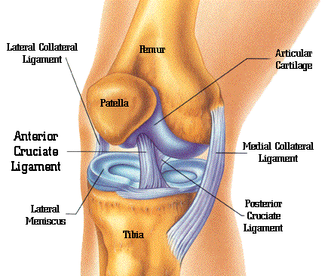
MCL Injuries (medial collateral ligament)
Cause: This injury occurs when excessive force is applied to the knee joint, most commonly due to falling forward while in the snowplow position. Catching the inside edge of the ski at the tip forces the lower leg away from the body while rotating the foot outward, damaging the ligament.
Treatment: Strains to this ligament can often heal with rest and rehab exercises.
ACL Injuries (anterior cruciate ligament)
Cause: There are three types of skiing falls that may lead to ACL injuries: the backward twisting fall (flexion-internal rotation or phantom foot), the forward twisting fall (valgus-external rotation), and off-balance jump (boot-induced anterior draw).
Treatment: Complete tears require surgery and months of healing and rehab.

Examples of Risk Factors
- Binding DIN set to high, or not functioning
- Not warming up , being unfit to ski
- Fatigue, dehydration, poor diet
- Skiing and riding too fast for conditions
- Slow backwards fall
- Hyperextension of the knee when edging
Prevention
Ensure bindings are functioning properly and are set at the correct DIN for weight and ability.
Ski and ride within your skill level for speed and terrain choices, and if you do fall, don’t attempt to resist. Relax and don’t try to stand until you have come to a complete stop.
Don’t attempt a jump unless you know where and how to land - land on both skis and keep your knees flexed.
Pre-season, build good core, hip and leg strength.
Additional Resources
- Safety Talk: Snow Sports Injury Reduction
- WorkSafeBC musculoskeletal injury info.
- facebook.com/FitForSnow/
- More Ski Area Resources: go2hr.ca/skisafety
Safety Tips
Maintain your own health and wellness, which means getting enough sleep, staying hydrated and snacking regularly throughout the day on small amounts of healthy food. Limit the amount of sugar in your diet. Fluctuating blood sugar is linked to an increased incidence of injury in ski resort employees.
Warm up for at least 10 minutes with easy dynamic movements within your range of motion and practice good alignment and core activation. Roll out and gently stretch sore muscles to restore length.
Use modern ski or snowboard equipment and keep it in good condition. Maintain your equipment – edges, wax and proper binding release settings. Make sure your ski boots are not worn down from walking on pavement.
Maintain a good stance - Start with your spine and pelvis in neutral, core activated, knees bent and hands in front of you. Your ankles, knees, and hips should comfortably flex and extend to absorb changing terrain.
Know how to fall, and how to stop after a fall.
Stay on runs that are within your skill level, and adjust accordingly to conditions. Take a lesson to progress. Skiing and snowboarding are complex skills that require practice to safely reach advanced levels.

