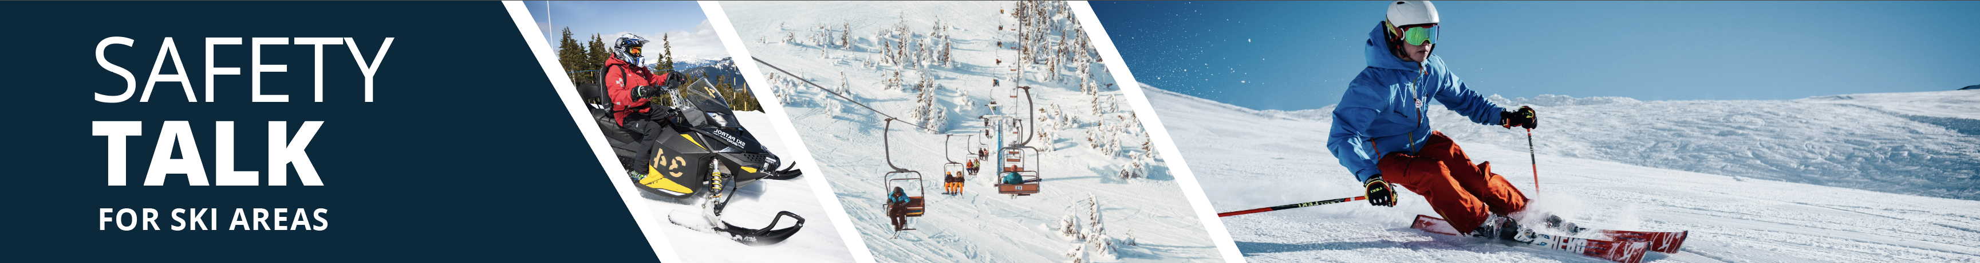

Critical Incident Stress Management (CISM)
Instructor Guide

Safety Talk Overview:
What & Why? Safety Talks are a method to refresh an employee’s knowledge and skills, maintain their interest in safety and illustrate the organization’s commitment to creating a healthy & safe work environment.

Who & When? Generally, these Safety Talk meetings are led by a supervisor, member of the JHSC, or Worker H&S Representative and should be mandatory for all crew members to attend. The content should be focused on a single topic. Safety Talks can be performed on a weekly basis or before the start of a new scope of work and should be about 15 minutes in duration.

go2HR developed this safety talk template for employers to customize and use for any topic in their organization. The Participant Handout should include information that you hope the worker will retain from the safety talk content and should be handed out during the safety talk for workers to reference later. Feel free to use it at your discretion.

What is Mountain ‘Critical Incident Stress Management’ (CISM)?
Designed to reduce the chances of long-term mental health struggles arising after a critical incident, CISM is a response program within the Canadian Mountain Community where peer responders facilitate in-person or virtual group debriefs and/or one-on-one conversations with individuals who need support after experiencing a critical incident during work.

Safety Talk Outline (using the handout attached):
1. Explain the following topics:
a. Critical incidents
b. Critical incident stress
c. Critical incident stress management
d. Peer responders
e. Initiating support
4. Discuss how CISM could be used at your company

Additional Resources
- Explore the website: www.mountaincism.ca
- Contact the team: hello@mountaincism.ca

Topic Overview:

Safety Talk Facilitator Guidance

Introduce the topic and why it’s important
Discuss the associated hazards and likely incidents
Tour the work zone identifying hazardous areas
Distribute the Participant Handout
Use the info above to guide the discussion
Document the talk using the Safety Talk Record
Explain what controls are used to minimize the risks
Remind employees about applicable PPE usage
Emphasize the importance of safe work procedures
Ask questions to generate group discussion
Answer any questions or concerns they might have
Set a good example by working safely at all time

Critical Incident Stress Management (CISM)
Safety Talk Record
Discussion Leader: | Date:
Department: | Time:

Attendees (Please print your name and sign beside it. If you are a contractor, also include your company name):

Near miss/incidents and investigations reviewed: ☐ None this month

Any questions or concerns from workers?

Action needed: | Person responsible: | Due date: | Completed date:

Supervisor/Manager print name & sign: | Date:

Reviewed by:

CRITICAL INCIDENT STRESS MANAGEMENT (CISM)
What is a ‘Critical Incident’? An event that has a traumatic impact sufficient enough
to overwhelm the usually effective coping skills of either an individual or a group.
For example, an injury or death of a client or coworker in the field, multi-casualty
incident, body recovery, suicide of a coworker, significant avalanche occurrence, or
inbounds incident.

What is ‘Critical Incident Stress’? Critical incidents are typically sudden, powerful
events that are outside the range of daily human experiences. Because these events
can be sudden and unexpected, they can cause acute and/or long-term stress on
the mental health of those involved with or close to the critical incident. Critical
incidents may produce a wide range of stress symptoms, which may appear
immediately at the scene, a few hours later or within days of an incident. Stress
symptoms usually occur in four different categories: Cognitive (thinking), Physical (body), Emotional (feelings) and Behavioral (actions). People may experience a range of symptoms to varying severity, and no two stress responses are the same.

What is ‘Critical Incident Stress Management’ (CISM)? Designed to reduce the chances of long-term mental health struggles arising after a critical incident, CISM is a response program where peer responders facilitate in-person or virtual group debriefs and/or one-on-one conversations with individuals needing support after a critical incident. CISM is not a replacement for professional support services such as counselling and therapy, nor is it a guarantee that longer lasting stress following trauma won’t occur. Seeking support through the CISM team and talking to our volunteer peers is an incredible step to take following the experience of a critical incident which can help to mitigate longer lasting impacts of trauma.

Who are the peer responders? Fellow mountain professionals who speak the same industry language, have done the same work, and have felt the same fears. Though they are trained members of the mountain community, they are not mental health professionals. They can connect you with further care if necessary.

Who can call for support? Seven mountain associations in Canada have joined together to offer this program to their members. All folks in the professional mountain community who are also active members (or work for an active member organization) of a participating mountain community association can connect for peer support services.

When is it best to call for support? It’s best to call and initiate support as soon after the incident as possible.

How can I initiate support? By calling 604-670-2772 (between 8 am – 8 pm) or emailing hello@mountaincism.ca.

How can I learn more? Visit www.mountaincism.ca or scan this QR Code to learn more and
find resources such as posters, brochures, and links to further support.
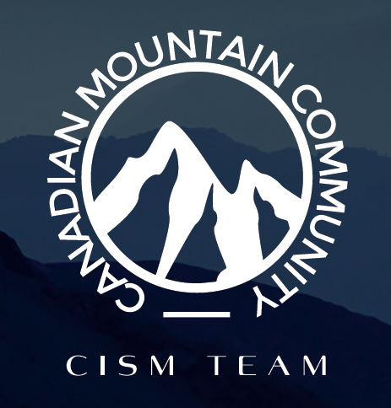
Participant Handout

For more information on this topic or if you have questions, contact your manager.

