Working Alone Check-In Procedure

This procedure outlines the required steps for checking in with workers who are working alone or in isolation. The purpose is to ensure their safety and to provide a timely response in the event of an emergency or missed check-in. This procedure applies to all staff who perform work alone, particularly during high-risk or isolated tasks.

Before the Solo/Isolated Work Begins:
- Identify and assess the solo/isolated work to determine the appropriate check-in frequency based on the nature of the work, location, and level of isolation.
- Ensure the worker has access to a reliable communication method (e.g., mobile phone, radio, check-in app).
- Designate a check-in contact person (usually a supervisor, manager, or dispatcher) responsible for initiating and responding to check-ins.
- Confirm the check-in schedule and emergency procedures for the worker.
- Ensure all affected workers know of the active working alone check-ins including the worker’s supervisor/manager and first aid attendant.

During the Solo/Isolated Work:
- The worker must check-in at the agreed intervals using the designated communication method.
- The check-in contact person must document each check-in using the Working Alone Check-in Log.
- If any concerns or hazards arise during the work, the worker must report them immediately for reassessment.

Missed Check-in Protocol:
- If a check-in is missed, the contact person must attempt to reach the worker immediately.
- If the worker cannot be reached within 10 minutes, follow the escalation protocol which may include:
  - Calling the worker’s personal phone and other available methods
  - Contacting supervisor, first aid attendant, and nearby workers, if applicable
  - Initiate a physical check-in by having someone visit the worksite
  - Contacting emergency services if necessary

After the Solo/Isolated Work Ends:
- The worker must complete a final check-out to confirm the work has ended safely.
- The check-in contact should log the final check-out time and close the record for the work.

Psychological Health & Safety:
Working alone can present psychological risks such as stress, anxiety, or feels of isolation. Supervisors and managers should regularly check in with lone workers about how they’re feeling, ensure procedures are working effectively, and offer mental health resources or support where needed.

Determining the Check-in Frequency:
The following matrix can be used to determine risk rating (adopted from Hazard ID & Risk Assessment):
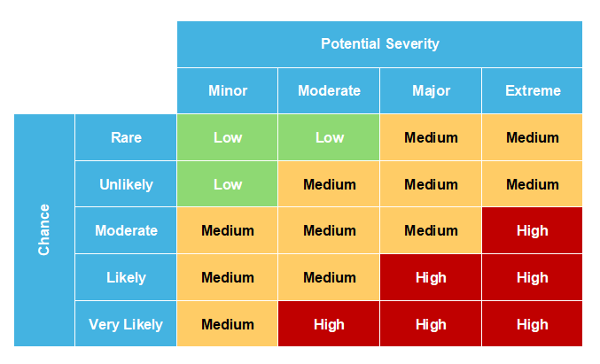
Based on the risk rating of the task, the frequency of check-in can be then determined using the chart below:
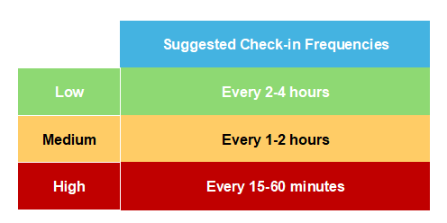

Training and Communication:
Workers and supervisors should be made aware of working alone procedures and their related responsibilities, including awareness of the areas of concern and how often workers/supervisors are expected to check-in.
Refresher training can occur annually or whenever there is a change in the procedure.

Procedure Administration:
This procedure is to be reviewed annually and revised as necessary. It may also be reviewed and revised at any time if:
- There are changes to Regulation
- A change in the work environment, tasks, or equipment introduces new applicable hazards
- An incident involving a lone worker occurs
- Procedures are reported to be working ineffectively

Date Implemented: By:
Date Reviewed/Revised: By:

Working Alone Check-In Log
This log is used to document check-ins for workers who are working alone or in isolation. Check-ins should begin at the start of the work and continue until the work is complete.
Check-in frequency is based on the assessed level of risk and location of the work.

Worker Information:
Worker Name:
Date:
Starting Location:
Route & Ending Location: (if applicable)
Projected Task Hours:
Preferred Contact Method:
Alternate Contact Method(s):
Task Risk Rating:
Check-in Frequency:

Check-In Log:
Time of  Check-In | Contact Method (Phone, Radio, etc.) | Person Contacted | Notes / Worker Status | Initials

Missed Check-in Protocol:
- If a check-in is missed, the contact person must attempt to reach the worker immediately.
- If the worker cannot be reached within 10 minutes, follow the escalation protocol which may include:
  - Calling the worker’s personal phone and other available methods
  - Contacting supervisor, first aid attendant, and nearby workers, if applicable
  - Initiate a physical check-in by having someone visit the worksite
  - Contacting emergency services if necessary
  - Document what happened

