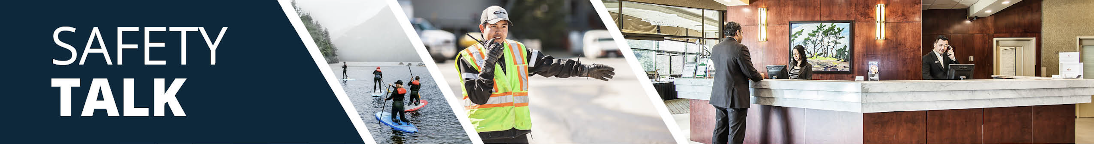
MSI Prevention and Safety for Making Beds – Room Attendants Instructor Guide

Safety Talk Overview:
What & Why? Safety Talks are a method to refresh an employee’s knowledge and skills, maintain their interest in safety and illustrate the organization’s commitment to creating a healthy & safe work environment.

Who & When? Generally, these Safety Talk meetings are led by a supervisor, member of the JHSC, or Worker H&S Representative and should be mandatory for all crew members to attend. The content should be focused on a single topic. Safety Talks can be performed on a weekly basis or before the start of a new scope of work and should be about 15 minutes in duration.

go2HR developed this safety talk template for employers to customize and use for any topic in their organization. The Participant Handout should include information that you hope the worker will retain from the safety talk content and should be handed out during the safety talk for workers to reference later. Feel free to use it at your discretion.

MSI Prevention and Safety for Making Beds Overview:
WorkSafeBC reports that over 50 percent of injuries in the accommodation industry involve room attendants. Making beds can be physically demanding and can put strain on the shoulders, back, and knees, leading to musculoskeletal injuries (MSIs) like strains and sprains. Repetitive bending, lifting, overexertion, overreaching, awkward postures and twisting motions (especially when not using proper techniques) can increase the risk of injury. It is important to provide workers with information on proper body positioning and techniques for making beds to help protect workers from injury.

Safety Talk Outline (using the handout below):
1. Introduce why it’s important to talk about safety and preventing MSIs when making beds
2. Explain the risk factors of bending, twisting, overreaching, awkward postures and lifting heavy mattresses
3. Outline control measures and safe practices to help prevent MSIs when making beds
4. Provide reminders on the importance of reporting early signs and symptoms of MSIs (e.g. discomfort or pain)
5. Encourage workers to discuss further, ask questions, and check out additional resources

Additional Resources:
See links and QR codes provided on the Participant Handout to WorkSafeBC’s short video series and infographic posters on MSI prevention and safety for making beds (available in multiple languages) along with additional resources from the Canadian Centre of Occupational Health and Safety (CCOHS) on Hotel Housekeeping.

Topic Overview

Safety Talk Facilitator Guidance

Introduce the topic and why it’s important
Discuss the associated hazards and likely incidents
Tour the work zone identifying hazardous areas
Distribute the Participant Handout
Use the info above to guide the discussion
Document the talk using the Safety Talk Record
Explain what controls are used to minimize the risks
Remind employees about applicable PPE usage
Emphasize the importance of safe work procedures
Ask questions to generate group discussion
Answer any questions or concerns they might have
Set a good example by working safely at all time

MSI Prevention and Safety for Making Beds – Room Attendants
Safety Talk Record
Discussion Leader: | Date:
Department: | Time:

Attendees (Please print your name and sign beside it. If you are a contractor, also include your company name):

Near miss/incidents and investigations reviewed: ☐ None this month

Any questions or concerns from workers?

Action needed: | Person responsible: | Due date: | Completed date:

Supervisor/Manager print name & sign: | Date:

Reviewed by:

MSI Prevention and Safety for Making Beds – Room Attendants
Why Talk About MSI Prevention and Safety for Making Beds?
WorkSafeBC reports that over 50 percent of injuries in the accommodation industry involve room attendants. Making beds can be physically demanding and can put strain on the shoulders, back, and knees, leading to musculoskeletal injuries (MSIs) like strains and sprains. Repetitive bending, lifting, overexertion, overreaching, awkward postures and twisting motions (especially when not using proper techniques) can increase the risk of injury. The purpose of this Safety Talk is to raise awareness and help to prevent injuries associated with making beds with a focus on MSI prevention.

Hazards and Common Injuries
There are many movements involved with making beds, injuries can be caused from improper techniques such as:
-Back injuries from bending at the waist or lifting improperly
-Shoulder injuries from overreaching across beds or forceful tucking in awkward postures
-Knee injuries from repeated squatting or kneeling in non-neutral postures and without support

Key Information and Safe Practices for Making Beds
-Inspect the bed visually for sharps or materials, wear gloves when removing previously used bedding
-Detach bedding carefully by walking around the bed, avoid stretching across the bed
-Place used bedding and linens directly into designated carts and bins
-Avoid putting linens on the floor to prevent tripping hazards and eliminating the need to bend over and pick it up
-Position your body close to the bed and area you are working on
-Use correct body positioning such as kneeling on one knee to reach lower levels, do not bend at your back
-Avoid lifting the mattress, use tucking techniques or work with a partner if lifting is needed
-Stuff pillows with your hands, instead of forcefully shaking to prevent overexertion injuries

Conversation Topics for the Team
-Ask your team, “What do you find most challenging when making beds?”
-Demonstrate and observe proper kneeling and tucking techniques
-Encourage use of the QR codes below to check out videos and infographics available in multiple languages
-Remind your team of the importance and process of reporting early signs and symptoms of MSIs

Additional Resources
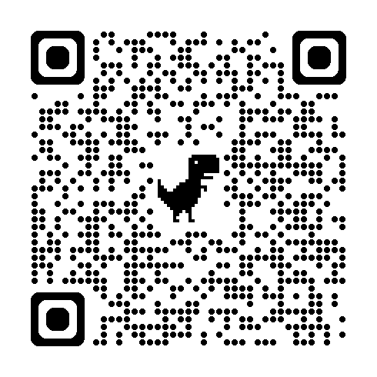 | 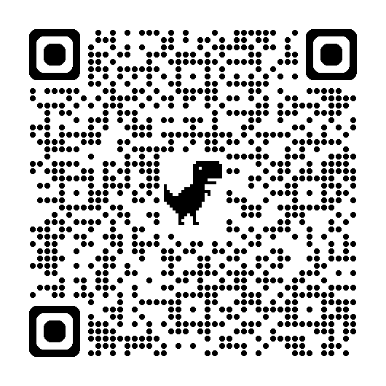 | 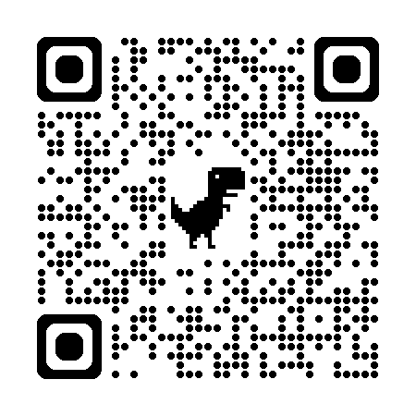
WorkSafeBC Video Series | WorkSafeBC Infographic Posters | CCOHS Hotel Housekeeping
Or visit: https://www.worksafebc.com/en/resources/health-safety/videos/room-attendants/full
Participant Handout

For more information on this topic or if you have questions, contact:

