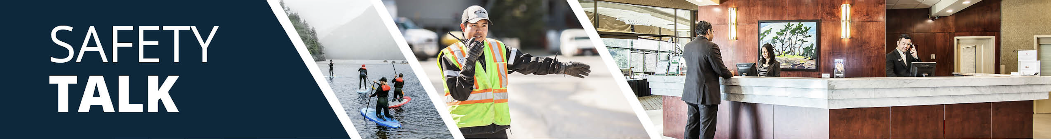
MSI Prevention and Safety for Cleaning Bathrooms – Room Attendants Instructor Guide

Safety Talk Overview:
What & Why? Safety Talks are a method to refresh an employee’s knowledge and skills, maintain their interest in safety and illustrate the organization’s commitment to creating a healthy & safe work environment.

Who & When? Generally, these Safety Talk meetings are led by a supervisor, member of the JHSC, or Worker H&S Representative and should be mandatory for all crew members to attend. The content should be focused on a single topic. Safety Talks can be performed on a weekly basis or before the start of a new scope of work and should be about 15 minutes in duration.

go2HR developed this safety talk template for employers to customize and use for any topic in their organization. The Participant Handout should include information that you hope the worker will retain from the safety talk content and should be handed out during the safety talk for workers to reference later. Feel free to use it at your discretion.

MSI Prevention and Safety for Cleaning Bathrooms Overview:
WorkSafeBC reports that over 50 percent of injuries in the accommodation industry involve room attendants. Tasks associated with cleaning bathrooms can put strain on the shoulders, back, and arms, leading to musculoskeletal injuries (MSIs) like strains and sprains. Awkward reaching, bending, and prolonged arm and shoulder use (especially when not using proper techniques or the correct tools) can increase the risk of injury. It is important to provide workers with information on proper body positioning and techniques for cleaning bathrooms to help protect workers from injury.

Safety Talk Outline (using the handout below):
1. Introduce why it’s important to talk about safety and preventing MSIs when cleaning bathrooms
2. Explain the risk factors of awkward reaching, bending, and prolonged arm and shoulder use
3. Outline control measures, tools and safe practices to help prevent MSIs when cleaning bathrooms
4. Provide reminders on the importance of reporting early signs and symptoms of MSIs (e.g. discomfort or pain)
5. Encourage workers to discuss further, ask questions, and check out additional resources

Additional Resources:
See links and QR codes provided on the Participant Handout to WorkSafeBC’s short video series and infographic posters on MSI prevention and safety for cleaning bathrooms (available in multiple languages) along with additional resources from the Canadian Centre of Occupational Health and Safety (CCOHS) on Hotel Housekeeping.

Topic Overview

Safety Talk Facilitator Guidance

Introduce the topic and why it’s important
Discuss the associated hazards and likely incidents
Tour the work zone identifying hazardous areas
Distribute the Participant Handout
Use the info above to guide the discussion
Document the talk using the Safety Talk Record
Explain what controls are used to minimize the risks
Remind employees about applicable PPE usage
Emphasize the importance of safe work procedures
Ask questions to generate group discussion
Answer any questions or concerns they might have
Set a good example by working safely at all time

MSI Prevention and Safety for Cleaning Bathrooms – Room Attendants
Safety Talk Record
Discussion Leader: | Date:
Department: | Time:

Attendees (Please print your name and sign beside it. If you are a contractor, also include your company name):

Near miss/incidents and investigations reviewed: ☐ None this month

Any questions or concerns from workers?

Action needed: | Person responsible: | Due date: | Completed date:

Supervisor/Manager print name & sign: | Date:

Reviewed by:

MSI Prevention and Safety for Cleaning Bathrooms – Room Attendants
Why Talk About MSI Prevention and Safety for Cleaning Bathrooms?
WorkSafeBC reports that over 50 percent of injuries in the accommodation industry involve room attendants. Tasks associated with cleaning bathrooms can put strain on the shoulders, back, and arms, leading to musculoskeletal injuries (MSIs). Awkward reaching, bending, and prolonged arm and shoulder use (especially when not using proper techniques or the correct tools) can increase the risk of injury. MSIs can occur suddenly or build up over time. The purpose of this Safety Talk is to raise awareness and help to prevent injuries associated with cleaning bathrooms with a focus on MSIs.

Hazards and Common Injuries
There are many movements involved with cleaning bathrooms. These include extending and overreaching with arms to scrub walls or reaching into tubs, and bending to clean floors or lower surfaces. In addition, awkward postures (e.g. reaching overhead, bending forward) for long periods, and slippery surfaces that can increase the risk of slips and falls.

Key Information and Safe Practices for Cleaning Bathrooms
-Plan your work by assessing the bathroom before starting work, check for water, spills, or clutter
-Choose the right cleaning product for the job to reduce time and effort needed
-Divide the bathroom into zones: high, medium, and low, alternating hand and other movements to avoid fatigue
-Work at chest height (neutral postures) avoiding unnecessary shoulder or neck strain when possible
-Never overreach or stretch beyond a safe distance, move your body closer to the required area instead
-Carefully stand in tubs to clean walls, do not put yourself at risk by balancing on edges or objects
-Wear non-slip footwear, and use non-slip mats if standing in tubs
-Use tools with telescoping handles to extend reach and minimize overreaching
-Take short posture breaks (micro-pauses) to relieve muscle strain
-When possible, bend one knee with a kneepad or squat instead of bending your back to access lower areas

Conversation Topics for the Team
-Ask your team, “What do you find most challenging when cleaning bathrooms?”
-Demonstrate and observe proper techniques and use of telescopic tools for cleaning bathrooms
-Encourage use of the QR codes below to check out videos and infographics available in multiple languages
-Remind your team of the importance and process of reporting early signs and symptoms of MSIs

Additional Resources
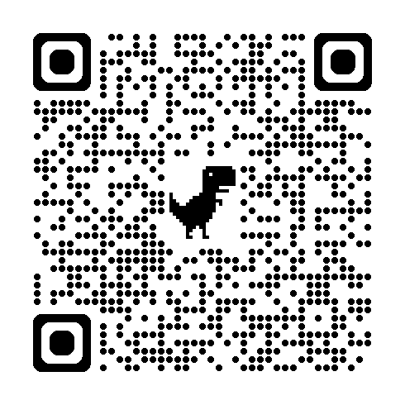 | 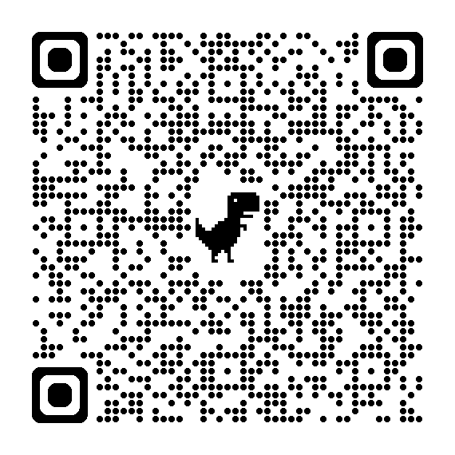 | 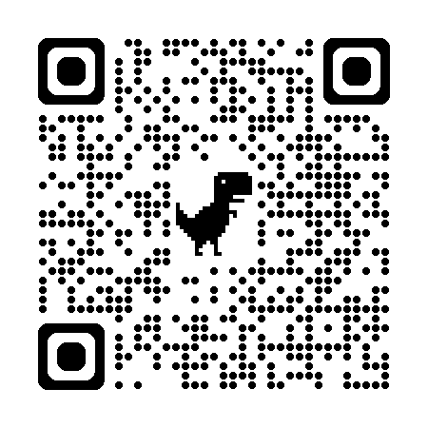
WorkSafeBC Video Series | WorkSafeBC Infographic Posters | CCOHS Hotel Housekeeping
Or visit: https://www.worksafebc.com/en/resources/health-safety/videos/room-attendants/full
Participant Handout

For more information on this topic or if you have questions, contact:

