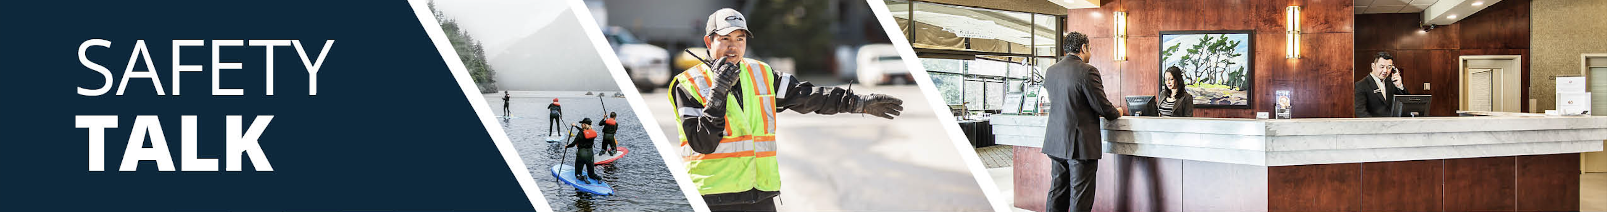
MSI Prevention and Safety for Cloth Wringing – Room Attendants Instructor Guide

Safety Talk Overview:
What & Why? Safety Talks are a method to refresh an employee’s knowledge and skills, maintain their interest in safety and illustrate the organization’s commitment to creating a healthy & safe work environment.

Who & When? Generally, these Safety Talk meetings are led by a supervisor, member of the JHSC, or Worker H&S Representative and should be mandatory for all crew members to attend. The content should be focused on a single topic. Safety Talks can be performed on a weekly basis or before the start of a new scope of work and should be about 15 minutes in duration.

go2HR developed this safety talk template for employers to customize and use for any topic in their organization. The Participant Handout should include information that you hope the worker will retain from the safety talk content and should be handed out during the safety talk for workers to reference later. Feel free to use it at your discretion.

MSI Prevention and Safety for Cloth Wringing Overview:
WorkSafeBC reports that over 50 percent of injuries in the accommodation industry involve room attendants. Wringing cloths may seem like a simple task, but it is a repetitive and high-frequency task that can cause musculoskeletal injuries (MSIs) over time. Repetitive twisting, excessive force, and awkward wrist bending can lead to strains, sprains, and long-term discomfort if improper techniques are used. When you use the proper techniques, strain to the small joints of the wrist can be reduced. It is important to provide workers with information on techniques for protecting workers from injury.

Safety Talk Outline (using the handout below):
1. Introduce why it’s important to talk about safety and preventing MSIs when wringing cloths
2. Explain the risk factors of twisting, excessive force, and awkward wrist bending when wringing cloths
3. Outline control measures and safe practices to help prevent MSIs when wringing cloths
4. Provide reminders on the importance of reporting early signs and symptoms of MSIs (e.g. discomfort or pain)
5. Encourage workers to discuss further, ask questions, and check out additional resources

Additional Resources:
See links and QR codes provided on the Participant Handout to WorkSafeBC’s short video series and infographic posters on MSI prevention and safety for cloth wringing (available in multiple languages) along with additional resources from the Canadian Centre of Occupational Health and Safety (CCOHS) on Hotel Housekeeping.

Topic Overview

Safety Talk Facilitator Guidance

Introduce the topic and why it’s important
Discuss the associated hazards and likely incidents
Tour the work zone identifying hazardous areas
Distribute the Participant Handout
Use the info above to guide the discussion
Document the talk using the Safety Talk Record
Explain what controls are used to minimize the risks
Remind employees about applicable PPE usage
Emphasize the importance of safe work procedures
Ask questions to generate group discussion
Answer any questions or concerns they might have
Set a good example by working safely at all time

MSI Prevention and Safety for Cloth Wringing – Room Attendants
Safety Talk Record
Discussion Leader: | Date:
Department: | Time:

Attendees (Please print your name and sign beside it. If you are a contractor, also include your company name):

Near miss/incidents and investigations reviewed: ☐ None this month

Any questions or concerns from workers?

Action needed: | Person responsible: | Due date: | Completed date:

Supervisor/Manager print name & sign: | Date:

Reviewed by:

MSI Prevention and Safety for Cloth Wringing – Room Attendants
Why Talk About MSI Prevention and Safety for Cloth Wringing?
WorkSafeBC reports that over 50 percent of injuries in the accommodation industry involve room attendants. Wringing cloths may seem like a simple task, but it is a repetitive and high-frequency task that can cause musculoskeletal injuries (MSIs) over time. Repetitive twisting, excessive force, and awkward wrist bending can lead to strains, sprains, and long-term discomfort if improper techniques are used. When you use the proper techniques, strain to the small joints of the wrist can be reduced. The purpose of this Safety Talk is to raise awareness and prevent injuries associated with cloth wringing with a focus on MSI prevention.

Hazards and Common Injuries
Wringing cloths is a repetitive and high-frequency task, injuries can be caused from improper techniques which include forceful squeezing and twisting which strains the small muscles and tendons, awkward wrist positions (e.g. bending too far forward or backward) and repetitive motion without rest can lead to cumulative injury over time.

Key Information and Safe Practices for Cloth Wringing
-Use smaller cloths that are easier to wring out and perform no more than two squeezes to wring out cloths
-Swap out cloths more frequently instead of over-wringing heavily soaked ones
-Where practical, use tools like wringer buckets to reduce manual effort
-Use a hand-over-hand squeezing technique (e.g. hold one hand above the other and squeeze downward)
-Start with wrists flexed and return to a neutral position while wringing, rather than forcing or overextending them
-Take micro-breaks and if you are wringing many cloths in a shift, shake out hands and wrists gently
-Always listen to early signs of fatigue (e.g. soreness, tingling, or weakness in the hands and wrists)

Conversation Topics for the Team
-Ask your team, “Are cloths large enough to be efficient, but small enough to be wrung out after 2 motions”
-Request a volunteer to demonstrate proper wringing technique and share strategies used to protect their wrists
-Encourage use of the QR codes below to check out videos and infographics available in multiple languages
-Remind your team of the importance and process of reporting early signs and symptoms of MSIs

Additional Resources
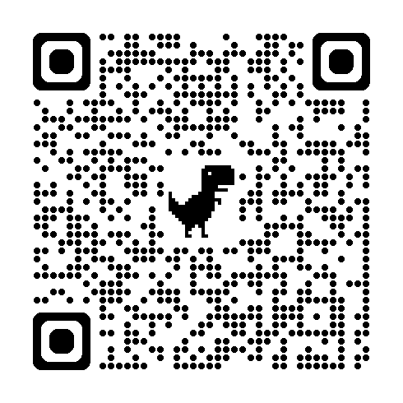 | 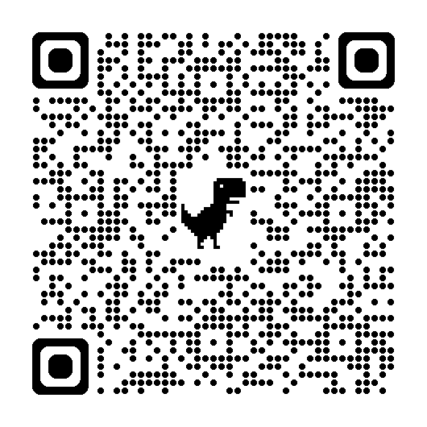 | 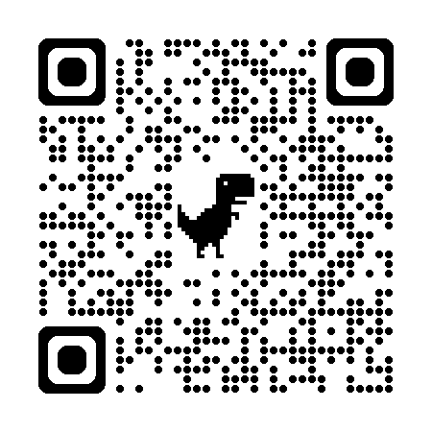
WorkSafeBC Video Series | WorkSafeBC Infographic Posters | CCOHS Hotel Housekeeping
Or visit: https://www.worksafebc.com/en/resources/health-safety/videos/room-attendants/full
Participant Handout

For more information on this topic or if you have questions, contact:

