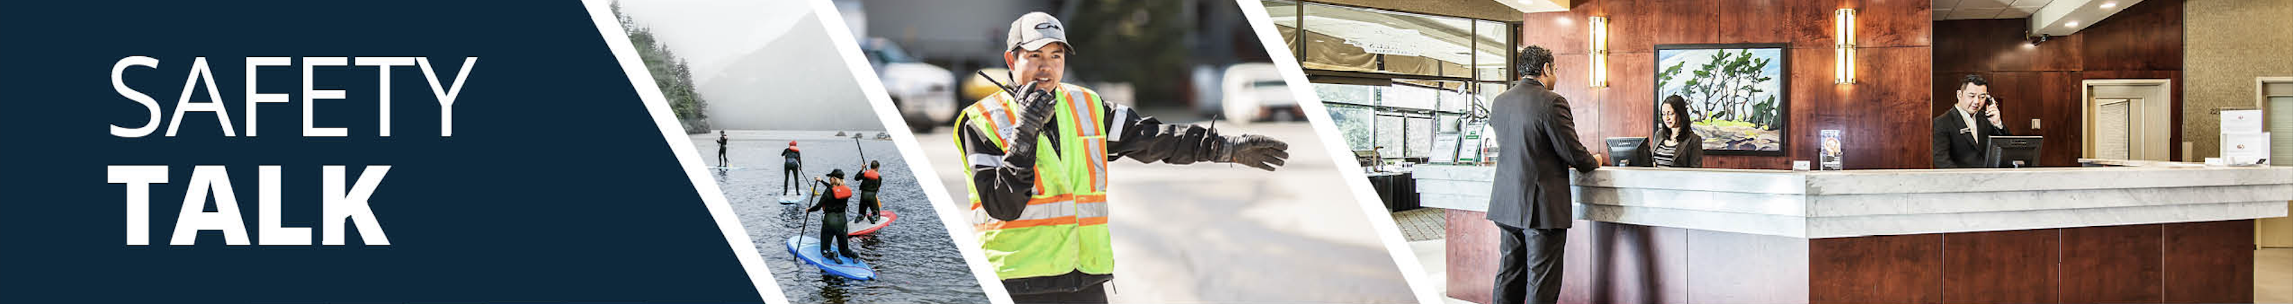
MSI Prevention and Safety for High Dusting – Room Attendants Instructor Guide

Safety Talk Overview:
What & Why? Safety Talks are a method to refresh an employee’s knowledge and skills, maintain their interest in safety and illustrate the organization’s commitment to creating a healthy & safe work environment.

Who & When? Generally, these Safety Talk meetings are led by a supervisor, member of the JHSC, or Worker H&S Representative and should be mandatory for all crew members to attend. The content should be focused on a single topic. Safety Talks can be performed on a weekly basis or before the start of a new scope of work and should be about 15 minutes in duration.

go2HR developed this safety talk template for employers to customize and use for any topic in their organization. The Participant Handout should include information that you hope the worker will retain from the safety talk content and should be handed out during the safety talk for workers to reference later. Feel free to use it at your discretion.

MSI Prevention and Safety for High Dusting Overview:
WorkSafeBC reports that over 50 percent of injuries in the accommodation industry involve room attendants. Dusting high surfaces can pose risk for musculoskeletal injuries (MSIs) due to prolonged, awkward and elevated postures of the arms, shoulders, and neck. Using the correct tools/equipment, working within a safe range of motion, and protecting your eyes can help minimize the risk of injury. It is important to provide workers with information on proper body positioning techniques along with the correct tools and equipment for dusting high surfaces to help protect workers from injury.

Safety Talk Outline (using the handout below):
1. Introduce why it’s important to talk about safety and preventing MSIs when dusting high surfaces
2. Explain the risk factors of prolonged overreaching, awkward postures, and falls
3. Outline control measures and safe practices to help prevent MSIs when dusting high surfaces
4. Provide reminders on the importance of reporting early signs and symptoms of MSIs (e.g. discomfort or pain)
5. Encourage workers to discuss further, ask questions, and check out additional resources

Additional Resources:
See links and QR codes provided on the Participant Handout to WorkSafeBC’s short video series and infographic posters on MSI prevention and safety for high dusting (available in multiple languages) along with additional resources from the Canadian Centre of Occupational Health and Safety (CCOHS) on Hotel Housekeeping.

Topic Overview

Safety Talk Facilitator Guidance

Introduce the topic and why it’s important
Discuss the associated hazards and likely incidents
Tour the work zone identifying hazardous areas
Distribute the Participant Handout
Use the info above to guide the discussion
Document the talk using the Safety Talk Record
Explain what controls are used to minimize the risks
Remind employees about applicable PPE usage
Emphasize the importance of safe work procedures
Ask questions to generate group discussion
Answer any questions or concerns they might have
Set a good example by working safely at all time

MSI Prevention and Safety for High Dusting – Room Attendants
Safety Talk Record
Discussion Leader: | Date:
Department: | Time:

Attendees (Please print your name and sign beside it. If you are a contractor, also include your company name):

Near miss/incidents and investigations reviewed: ☐ None this month

Any questions or concerns from workers?

Action needed: | Person responsible: | Due date: | Completed date:

Supervisor/Manager print name & sign: | Date:

Reviewed by:

MSI Prevention and Safety for High Dusting – Room Attendants
Why Talk About MSI Prevention and Safety for High Dusting?
WorkSafeBC reports that over 50 percent of injuries in the accommodation industry involve room attendants. Dusting high surfaces can pose risk for musculoskeletal injuries (MSIs) due to prolonged, awkward and elevated postures of the arms, shoulders, and neck. Using the correct tools and equipment, working within a safe range of motion, and using proper body positioning techniques can help minimize the risk of injury. The purpose of this Safety Talk is to raise awareness and prevent injuries associated with high dusting with a focus on MSI prevention.

Hazards and Common Injuries
The hazards and common injuries for high dusting include holding tools overhead which can cause increased fatigue and muscle strain, and can contribute to awkward neck and shoulder positions. Other hazards involve falls if inappropriate equipment (e.g. chairs or furniture) is used, or exposure to dust and debris falling into the eyes or face.

Key Information and Safe Practices for High Dusting
-Plan your work to alternate high and low dusting tasks to change your body posture frequently
-Choose the right tools, use dusting tools with telescoping handles to reduce overhead reaching
-Choose the right equipment, use a safe, stable stepstool (if needed) and never stand on chairs or furniture
-Position your body and equipment so you can work with minimal reaching and bending
-Keep your elbows close to your body and work with your in hands in front of you (neutral postures)
-Stand slightly to the side of the dusting area to maintain a neutral neck posture and avoid dust in your eyes
-Wear safety glasses if dust or debris is likely to fall
-Perform high dusting in shorter increments and take posture breaks to relax the shoulders and neck

Conversation Topics for the Team
-Ask your team, “What do you find most challenging when preforming high dusting?”
-Demonstrate and observe standing slightly to the side, keeping elbows close (neutral postures) while dusting
-Reinforce the importance of choosing safe equipment (e.g. stepstools) and not standing on furniture
-Encourage use of the QR codes below to check out videos and infographics available in multiple languages
-Remind your team of the importance and process of reporting early signs and symptoms of MSIs

Additional Resources
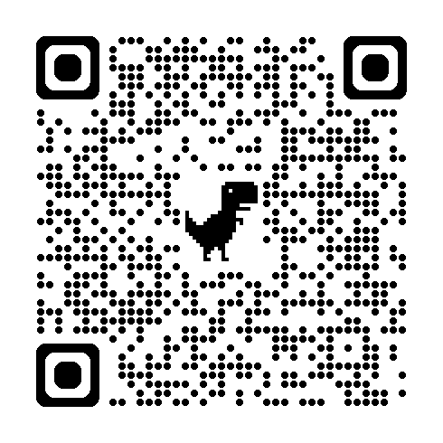 | 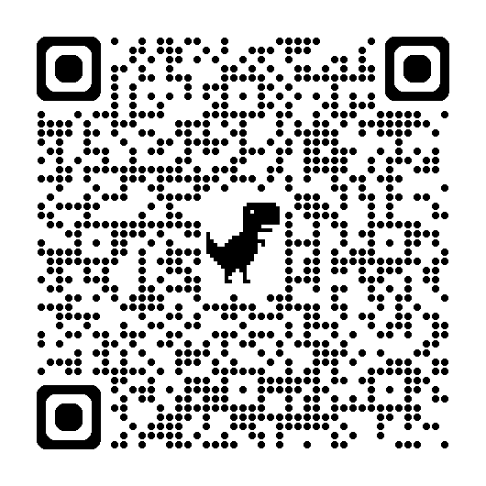 | 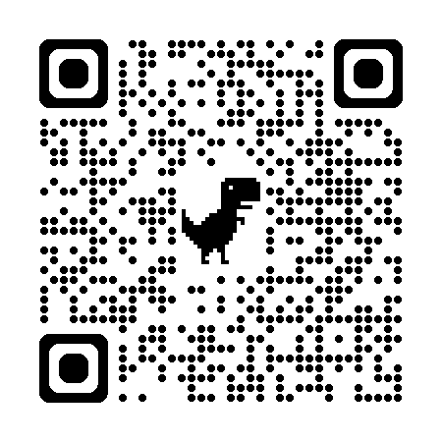
WorkSafeBC Video Series | WorkSafeBC Infographic Posters | CCOHS Hotel Housekeeping
Or visit: https://www.worksafebc.com/en/resources/health-safety/videos/room-attendants/full
Participant Handout

For more information on this topic or if you have questions, contact:

