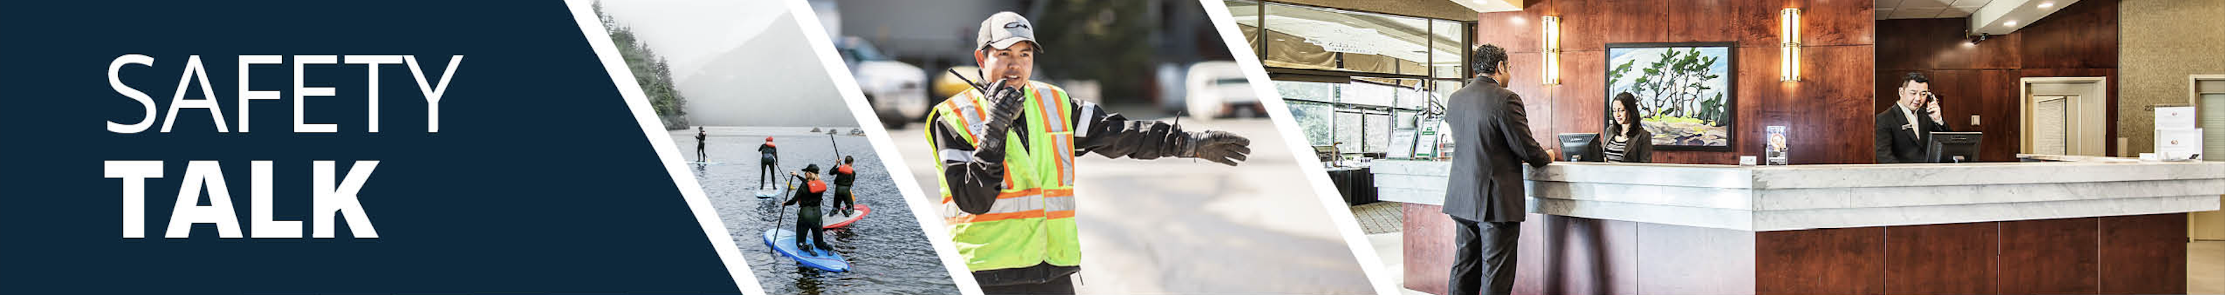
MSI Prevention and Safety for Emptying Waste – Room Attendants Instructor Guide

Safety Talk Overview:
What & Why? Safety Talks are a method to refresh an employee’s knowledge and skills, maintain their interest in safety and illustrate the organization’s commitment to creating a healthy & safe work environment.

Who & When? Generally, these Safety Talk meetings are led by a supervisor, member of the JHSC, or Worker H&S Representative and should be mandatory for all crew members to attend. The content should be focused on a single topic. Safety Talks can be performed on a weekly basis or before the start of a new scope of work and should be about 15 minutes in duration.

go2HR developed this safety talk template for employers to customize and use for any topic in their organization. The Participant Handout should include information that you hope the worker will retain from the safety talk content and should be handed out during the safety talk for workers to reference later. Feel free to use it at your discretion.

MSI Prevention and Safety for Emptying Waste Overview:
WorkSafeBC reports that over 50 percent of injuries in the accommodation industry involve room attendants. Emptying waste bins can cause musculoskeletal injuries (MSIs) if not handled properly. Waste bins can shift unexpectedly and be unpredictable in weight, or may even contain hazardous material (e.g. glass or needles). Improper lifting, especially without checking the load first, can cause injuries to the back, shoulders, wrists, and hands. It is important to provide workers with information on precautions and safe lifting techniques for emptying waste to help protect from injury.

Safety Talk Outline (using the handout below):
1. Introduce why it’s important to talk about safety and preventing MSIs when emptying waste containers
2. Explain the risk factors of unpredictability in weight and contents, and that the weight could shift unexpectedly
3. Outline control measures and safe practices to help prevent MSIs when emptying waste containers
4. Provide reminders on the importance of reporting early signs and symptoms of MSIs (e.g. discomfort or pain)
5. Encourage workers to discuss further, ask questions, and check out additional resources

Additional Resources:
See links and QR codes provided on the Participant Handout to WorkSafeBC’s short video series and infographic posters on MSI prevention and safety for emptying waste containers (available in multiple languages) along with additional resources from the Canadian Centre of Occupational Health and Safety (CCOHS) on Hotel Housekeeping.

Topic Overview

Safety Talk Facilitator Guidance

Introduce the topic and why it’s important
Discuss the associated hazards and likely incidents
Tour the work zone identifying hazardous areas
Distribute the Participant Handout
Use the info above to guide the discussion
Document the talk using the Safety Talk Record
Explain what controls are used to minimize the risks
Remind employees about applicable PPE usage
Emphasize the importance of safe work procedures
Ask questions to generate group discussion
Answer any questions or concerns they might have
Set a good example by working safely at all time

MSI Prevention and Safety for Emptying Waste – Room Attendants
Safety Talk Record
Discussion Leader: | Date:
Department: | Time:

Attendees (Please print your name and sign beside it. If you are a contractor, also include your company name):

Near miss/incidents and investigations reviewed: ☐ None this month

Any questions or concerns from workers?

Action needed: | Person responsible: | Due date: | Completed date:

Supervisor/Manager print name & sign: | Date:

Reviewed by:

MSI Prevention and Safety for Emptying Waste – Room Attendants
Why Talk About MSI Prevention and Safety for Emptying Waste?
WorkSafeBC reports that over 50 percent of injuries in the accommodation industry involve room attendants. Emptying waste bins can cause musculoskeletal injuries (MSIs) if not handled properly. Waste bins can shift unexpectedly and be unpredictable in weight, or may even contain hazardous material (e.g. broken glass or needles). The purpose of this Safety Talk is to raise awareness and prevent injuries associated with emptying waste containers with a focus on MSIs.

Hazards and Common Injuries
MSIs can occur when emptying waste bins if a container is heavier than expected, if the contents shift suddenly, or if poor lifting techniques are used. Improper lifting, especially without checking the load first, can cause injuries to the back, shoulders, wrists, and hands. Other hazards involve hidden sharp objects (e.g. broken glass or needles) which could cause cuts, lacerations or punctures, or exposures to other unknown hazardous or biological materials.

Key Information and Safe Practices for Emptying Waste Containers
-Always wear protective gloves when handling waste
-Use smaller bags or containers along with recycling sorters (when possible) to keep loads manageable
-Plan your route and keep walkways clear to avoid tripping hazards when carrying waste
-Tilt or gently pull the container to check its weight before lifting or moving it
-Visually inspect contents for sharp or dangerous objects, never push down on waste materials to compress it
-Use proper lifting techniques which includes bending your knees, and keeping your back straight
-Lift with both hands while keeping your wrists neutral
-If a waste container or item is too heavy, ask for help or use mechanical aids like dollies or carts

Conversation Topics for the Team
-Ask your team, "Have you ever been surprised by the weight of a waste bin or saw something unexpected?"
-Invite a worker to demonstrate safe lifting, emphasize importance to bend the knees and keep the back straight
-Allow workers to practice checking the weight before lifting, and demonstrating safe lifting techniques
-Encourage use of the QR codes below to check out videos and infographics available in multiple languages
-Remind your team of the importance and process of reporting early signs and symptoms of MSIs

Additional Resources
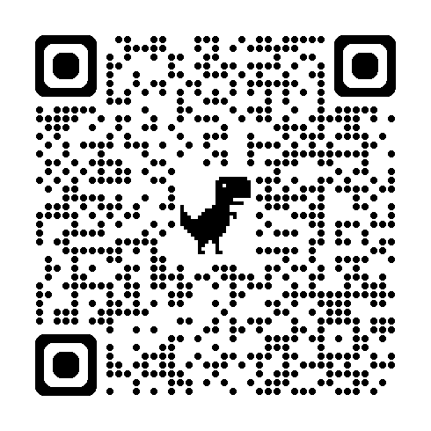 | 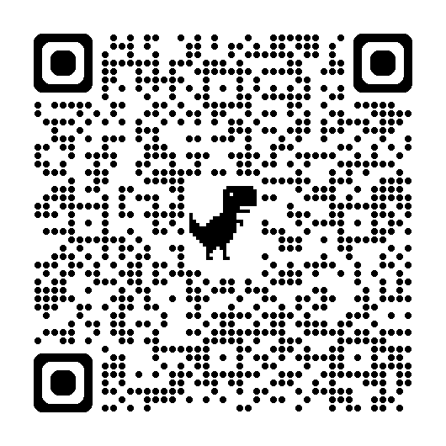 | 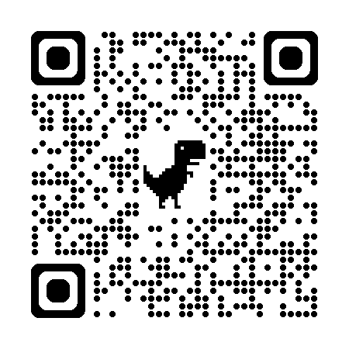
WorkSafeBC Video Series | WorkSafeBC Infographic Posters | CCOHS Hotel Housekeeping
Or visit: https://www.worksafebc.com/en/resources/health-safety/videos/room-attendants/full
Participant Handout

For more information on this topic or if you have questions, contact:

