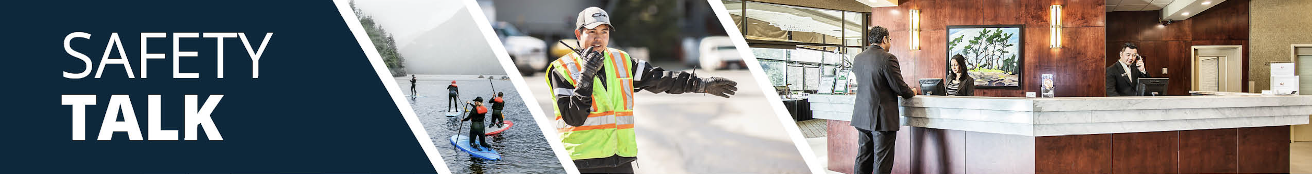
MSI Prevention and Safety for Vacuuming – Room Attendants Instructor Guide

Safety Talk Overview:
What & Why? Safety Talks are a method to refresh an employee’s knowledge and skills, maintain their interest in safety and illustrate the organization’s commitment to creating a healthy & safe work environment.

Who & When? Generally, these Safety Talk meetings are led by a supervisor, member of the JHSC, or Worker H&S Representative and should be mandatory for all crew members to attend. The content should be focused on a single topic. Safety Talks can be performed on a weekly basis or before the start of a new scope of work and should be about 15 minutes in duration.

go2HR developed this safety talk template for employers to customize and use for any topic in their organization. The Participant Handout should include information that you hope the worker will retain from the safety talk content and should be handed out during the safety talk for workers to reference later. Feel free to use it at your discretion.

MSI Prevention and Safety for Vacuuming Overview:
WorkSafeBC reports that over 50 percent of injuries in the accommodation industry involve room attendants. Vacuuming can lead to musculoskeletal injuries (MSIs) if proper body positioning and movement techniques are not used. Safe practices like keeping a neutral posture, walking with the vacuum, and minimizing twisting motions can help to prevent injury. It is important to provide workers with information on proper body positioning and movement techniques for vacuuming to help protect workers from injury.

Safety Talk Outline (using the handout below):
1. Introduce why it’s important to talk about safety and preventing MSIs when vacuuming
2. Explain the risk factors of repetitive twisting, overreaching, awkward postures, and trip and fall hazards
3. Outline control measures and safe practices to help prevent MSIs and cord management when vacuuming
4. Provide reminders on the importance of reporting early signs and symptoms of MSIs (e.g. discomfort or pain)
5. Encourage workers to discuss further, ask questions, and check out additional resources

Additional Resources:
See links and QR codes provided on the Participant Handout to WorkSafeBC’s short video series and infographic posters on MSI prevention and safety for vacuuming (available in multiple languages) along with additional resources from the Canadian Centre of Occupational Health and Safety (CCOHS) on Hotel Housekeeping.

Topic Overview

Safety Talk Facilitator Guidance

Introduce the topic and why it’s important
Discuss the associated hazards and likely incidents
Tour the work zone identifying hazardous areas
Distribute the Participant Handout
Use the info above to guide the discussion
Document the talk using the Safety Talk Record
Explain what controls are used to minimize the risks
Remind employees about applicable PPE usage
Emphasize the importance of safe work procedures
Ask questions to generate group discussion
Answer any questions or concerns they might have
Set a good example by working safely at all time

MSI Prevention and Safety for Vacuuming – Room Attendants
Safety Talk Record
Discussion Leader: | Date:
Department: | Time:

Attendees (Please print your name and sign beside it. If you are a contractor, also include your company name):

Near miss/incidents and investigations reviewed: ☐ None this month

Any questions or concerns from workers?

Action needed: | Person responsible: | Due date: | Completed date:

Supervisor/Manager print name & sign: | Date:

Reviewed by:

MSI Prevention and Safety for Vacuuming – Room Attendants
Why Talk About MSI Prevention and Safety for Vacuuming?
WorkSafeBC reports that over 50 percent of injuries in the accommodation industry involve room attendants. Vacuuming can lead to musculoskeletal injuries (MSIs) if proper body positioning and movement techniques are not used. Safe practices like keeping a neutral posture, walking with the vacuum, and minimizing twisting motions can help to prevent injury. The purpose of this Safety Talk is to raise awareness and prevent injuries associated with vacuuming with a focus on MSI prevention.

Hazards and Common Injuries
The hazards and common injuries for vacuuming include repetitive twisting of the back when turning the vacuum, overreaching or awkward bending forward, as well as arm and shoulder strain from wide, repetitive movements. Other hazards involve tripping hazards from poorly managed power cords or moving parts of the vacuum components.

Key Information and Safe Practices for Vacuuming
-Use lightweight vacuum models where possible and ensure wheels are functioning without difficulty
-Inspect vacuum and cords before use, never attempt to open up components of a vacuum while it is plugged in
-Clear a path by moving light furniture and objects out of the way before you vacuum
-Vacuum smaller zones and sections at a time to reduce fatigue
-Stand upright and avoid bending forward, keep elbows close to your body and maintain neutral postures
-Walk the vacuum (use your legs) rather than relying on your arms or your back to change vacuum direction
-Maintain a neutral posture, avoid twisting or overreaching and use your body weight to move the vacuum
-Manage power cords carefully to prevent tripping, secure in your free hand when needed

Conversation Topics for the Team
-Ask your team, “What makes vacuuming harder or more tiring for you?"
-Demonstrate and observe walking the vacuum instead of pushing and pulling only with the arms
-Encourage use of the QR codes below to check out videos and infographics available in multiple languages
-Remind your team of the importance and process of reporting early signs and symptoms of MSIs

Additional Resources
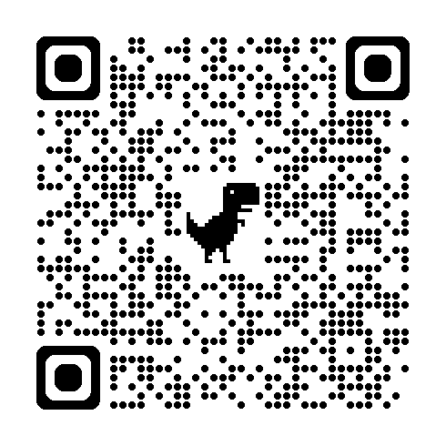 | 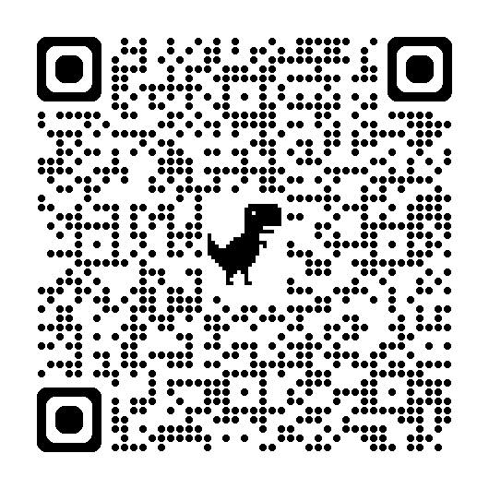 | 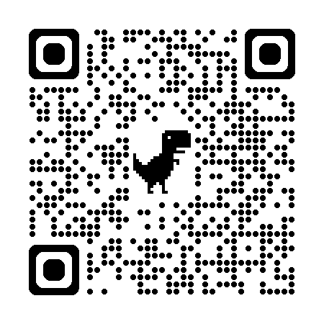
WorkSafeBC Video Series | WorkSafeBC Infographic Posters | CCOHS Hotel Housekeeping
Or visit: https://www.worksafebc.com/en/resources/health-safety/videos/room-attendants/full
Participant Handout

For more information on this topic or if you have questions, contact:

