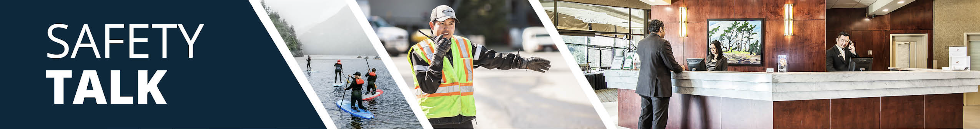

MSI Prevention - Pushing and Pulling
Instructor Guide

Safety Talk Overview:
What & Why? Safety Talks are a method to refresh an employee’s knowledge and skills, maintain their interest in safety and illustrate the organization’s commitment to creating a healthy & safe work environment.

Who & When? Generally, these Safety Talk meetings are led by a supervisor, member of the JHSC, or Worker H&S Representative and should be mandatory for all crew members to attend. The content should be focused on a single topic. Safety Talks can be performed on a weekly basis or before the start of a new scope of work and should be about 15 minutes in duration.

go2HR developed this safety talk template for employers to customize and use for any topic in their organization. The Participant Handout should include information that you hope the worker will retain from the safety talk content and should be handed out during the safety talk for workers to reference later. Feel free to use it at your discretion.

MSI Prevention for Pushing and Pulling Overview:
Musculoskeletal Injuries (MSIs) are one of the most common workplace injuries and can result from activities like pushing and pulling carts, bins, or equipment. These tasks may appear low risk but can cause significant strain to the back, shoulders, and arms if not performed correctly. In fact, OHS Alberta reports that between 9 and 20 percent of injury claims for low back pain are linked to pushing and pulling tasks. Preventing MSIs starts with understanding how to move loads in a safer way by using proper equipment, reducing strain and applying good body mechanics.

Safety Talk Outline (using the handout below):
1. Introduce why it’s important to talk about MSI prevention and how it relates to pushing and pulling tasks
2. Explain how improper pushing and pulling can increase risk factors associated with MSIs
3. Outline safe practices and actions for safe pushing and pulling to help prevent MSIs
4. Provide reminders on the importance of reporting early signs and symptoms of MSIs (e.g. discomfort or pain)
5. Encourage workers to discuss further, ask questions, and check out additional resources

Additional Resources:
-WorkSafeBC Push/Pull/Carry Calculator and WorkSafeBC MSI Prevention Guidance: Pushing and Pulling
-OHS Alberta Ergonomics Resource Portal

Topic Overview

Safety Talk Facilitator Guidance

Introduce the topic and why it’s important
Discuss the associated hazards and likely incidents
Tour the work zone identifying hazardous areas
Distribute the Participant Handout
Use the info above to guide the discussion
Document the talk using the Safety Talk Record
Explain what controls are used to minimize the risks
Remind employees about applicable PPE usage
Emphasize the importance of safe work procedures
Ask questions to generate group discussion
Answer any questions or concerns they might have
Set a good example by working safely at all time

MSI Prevention - Pushing and Pulling
Safety Talk Record
Discussion Leader: | Date:
Department: | Time:

Attendees (Please print your name and sign beside it. If you are a contractor, also include your company name):

Near miss/incidents and investigations reviewed: ☐ None this month

Any questions or concerns from workers?

Action needed: | Person responsible: | Due date: | Completed date:

Supervisor/Manager print name & sign: | Date:

Reviewed by:

MSI Prevention - Pushing and Pulling
Why Talk About MSI Prevention and Specifically Pushing and Pulling Risks?
Musculoskeletal Injuries (MSIs) are one of the most common workplace injuries and can result from activities like pushing and pulling carts, bins, or equipment. These tasks may appear low risk but can cause significant strain to the back, shoulders, and arms if not performed correctly. In fact, OHS Alberta reports that between 9 and 20 percent of injury claims for low back pain are linked to pushing and pulling tasks. Preventing MSIs starts with understanding how to move loads in a safer way by using proper equipment, reducing strain and applying good body mechanics.

Hazards Associated with Improper Pushing and Pulling
MSI risk factors associated with improper pushing and pulling can include overexertion injuries, and awkward body postures, especially when pulling a load behind the body or walking backwards. In addition to MSI risk factors, other hazards involved with pushing and pulling include slips, trips, or falls due to obstructed or uneven surfaces, and the potential for crush injuries from carts or equipment rolling over feet or pinching fingers against walls or doorframes.

General Control Measures for Prevention
Push, don’t pull – pushing allows better use of body weight reducing awkward shoulder and arm positions. This allows the person to face forward and keep the load in front. In addition, improved body mechanics when pushing include:
-Limit load weight and size when possible, and ensure loads are secure and stable to prevent shifting or tipping.
-Use both hands and keep arms close to the body maintaining a neutral posture.
-Break large loads into smaller, more manageable trips, and rotate pushing/pulling tasks when possible.
-Wear non-slip, supportive footwear, and consider gloves to improve grip and comfort.
In addition to using proper body mechanics, check and optimize equipment to ease movement. This includes inspecting equipment regularly for issues like damaged wheels or loose handles, and using functional wheels or casters suited to the flooring and load type. Keep paths clear of obstacles and avoid using carts on sloped, soft, or uneven surfaces.

Conversation Topics for the Team
-Ask your team, “What are some situations where you push or pull heavy objects, carts or equipment at work?”
-Further to the above, “Are there surfaces, locations or equipment that make this more difficult or strenuous?”
-Use the WorkSafeBC push/pull calculator to assess current practices, identify areas to improve
-Remind your team of the importance and process of reporting early signs and symptoms of MSIs

Additional Resources
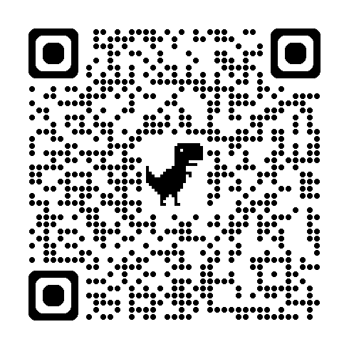 | 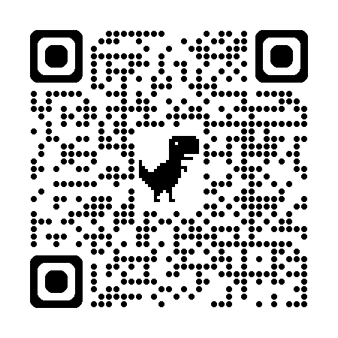 | 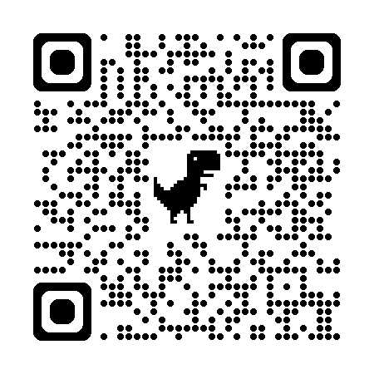
WorkSafeBC Push/Pull/Carry Calculator | WorkSafeBC MSI Prevention | CCOHS MSI Prevention
Or visit: https://www.worksafebc.com/en/health-safety/hazards-exposures/ergonomics
Participant Handout

For more information on this topic or if you have questions, contact:

