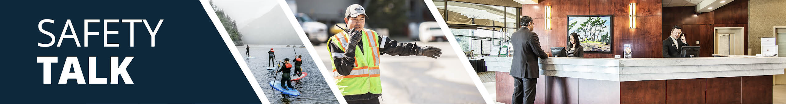

MSI Prevention - Safe Lifting and Carrying
Instructor Guide

Safety Talk Overview:
What & Why? Safety Talks are a method to refresh an employee’s knowledge and skills, maintain their interest in safety and illustrate the organization’s commitment to creating a healthy & safe work environment.

Who & When? Generally, these Safety Talk meetings are led by a supervisor, member of the JHSC, or Worker H&S Representative and should be mandatory for all crew members to attend. The content should be focused on a single topic. Safety Talks can be performed on a weekly basis or before the start of a new scope of work and should be about 15 minutes in duration.

go2HR developed this safety talk template for employers to customize and use for any topic in their organization. The Participant Handout should include information that you hope the worker will retain from the safety talk content and should be handed out during the safety talk for workers to reference later. Feel free to use it at your discretion.

MSI Prevention for Safe Lifting and Carrying Overview:
Lifting and carrying are common tasks in many workplaces, but when done improperly, they can lead to serious Musculoskeletal Injuries (MSIs). These injuries can affect the back, shoulders, arms, and other soft tissues, and are among the leading causes of lost time at work. There are no exact weight limits for lifting tasks because many factors can influence the risk of injury, including the size and shape of the object, distance carried, body posture, and individual factors of the worker.

Safety Talk Outline (using the handout below):
1. Introduce why it’s important to talk about MSI prevention and how it relates to lifting and carrying tasks
2. Explain how improper lifting and carrying can increase risk factors associated with MSIs
3. Outline safe practices and actions for safe lifting and carrying to help prevent MSIs
4. Provide reminders on the importance of reporting early signs and symptoms of MSIs (e.g. discomfort or pain)
5. Encourage workers to discuss further, ask questions, and check out additional resources

Additional Resources:
-WorkSafeBC Lift/Lower Calculator and WorkSafeBC Safe Lifting and Handling
-OHS Alberta Ergonomics Resource Portal and Lifting Assessment Tool

Topic Overview

Safety Talk Facilitator Guidance

Introduce the topic and why it’s important
Discuss the associated hazards and likely incidents
Tour the work zone identifying hazardous areas
Distribute the Participant Handout
Use the info above to guide the discussion
Document the talk using the Safety Talk Record
Explain what controls are used to minimize the risks
Remind employees about applicable PPE usage
Emphasize the importance of safe work procedures
Ask questions to generate group discussion
Answer any questions or concerns they might have
Set a good example by working safely at all time

MSI Prevention - Safe Lifting and Carrying
Safety Talk Record
Discussion Leader: | Date:
Department: | Time:

Attendees (Please print your name and sign beside it. If you are a contractor, also include your company name):

Near miss/incidents and investigations reviewed: ☐ None this month

Any questions or concerns from workers?

Action needed: | Person responsible: | Due date: | Completed date:

Supervisor/Manager print name & sign: | Date:

Reviewed by:

MSI Prevention - Safe Lifting and Carrying
Why Talk About MSI Prevention and Specifically Lifting and Carrying Risks?
Lifting and carrying are common tasks, but when done improperly, they can lead to serious Musculoskeletal Injuries (MSIs). These injuries can affect the back, shoulders, arms, and other soft tissues, and are among the leading causes of lost time at work. There are no exact weight limits for lifting tasks because many factors can influence the risk of injury, including the size and shape of the object, distance carried, body posture, and individual factors of the worker.

Hazards Associated with Improper Lifting and Carrying
Manual handling tasks such as lifting, lowering, carrying, holding, pulling, and supporting loads can generally lead to two key types of injury hazards: (1) overexertion caused by too much force or stretching beyond your capacity, and (2) overuse from repetitive stress from frequent or prolonged lifting. In addition, common risk factors include:
-Lifting or carrying awkwardly shaped or heavy items, and lifting above shoulder height or below knee level.
-Carrying objects far from the body, and twisting or reaching during the lift and carry.

General Control Measures for Prevention
-Plan the lift by knowing your route, checking for obstacles, confirming adequate clearance and lighting.
-Break loads into smaller, manageable pieces and use mechanical aids like carts or dollies when possible.
-Get close to the load and ensure a firm and secure grip, keep it as close and secure to your body as possible.
-Store frequently used items at waist height to reduce bending or reaching.
-Try to lift from waist height, and avoid lifting from the ground or above shoulders when possible.
-Keep your back straight and avoid twisting, and bend your knees, not your back and use your legs to lift.
-Lift smoothly and avoid jerking and twisting movements. If you need to turn, pivot with your feet.
-Adjust tasks to match worker abilities and physical limitations, and ask for help when needed.
-Use team communication when lifting together, coordinate timing of the lift and when lowering the item.

Conversation Topics for the Team
-Ask your team, “What are some situations that cause you to lift or carry heavy objects or equipment at work?”
-Further to the above, “Did anything make it harder?”, and/or “What could make it easier?”
-Use the WorkSafeBC lift/lower calculator to assess current practices, identify areas to improve
-Remind your team of the importance and process of reporting early signs and symptoms of MSIs

Additional Resources
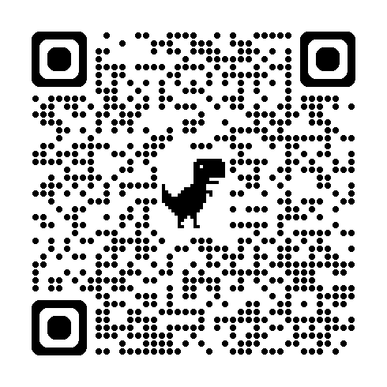 | 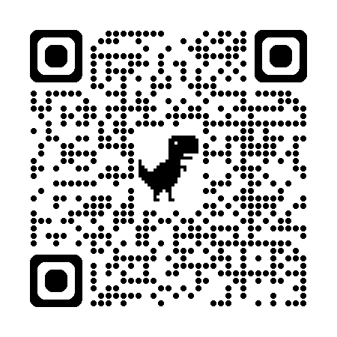 | 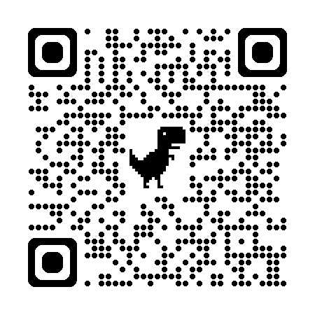
WorkSafeBC Lift/Lower Calculator | WorkSafeBC MSI Prevention | CCOHS MSI Prevention
Or visit: https://www.worksafebc.com/en/health-safety/hazards-exposures/ergonomics
Participant Handout

For more information on this topic or if you have questions, contact:

